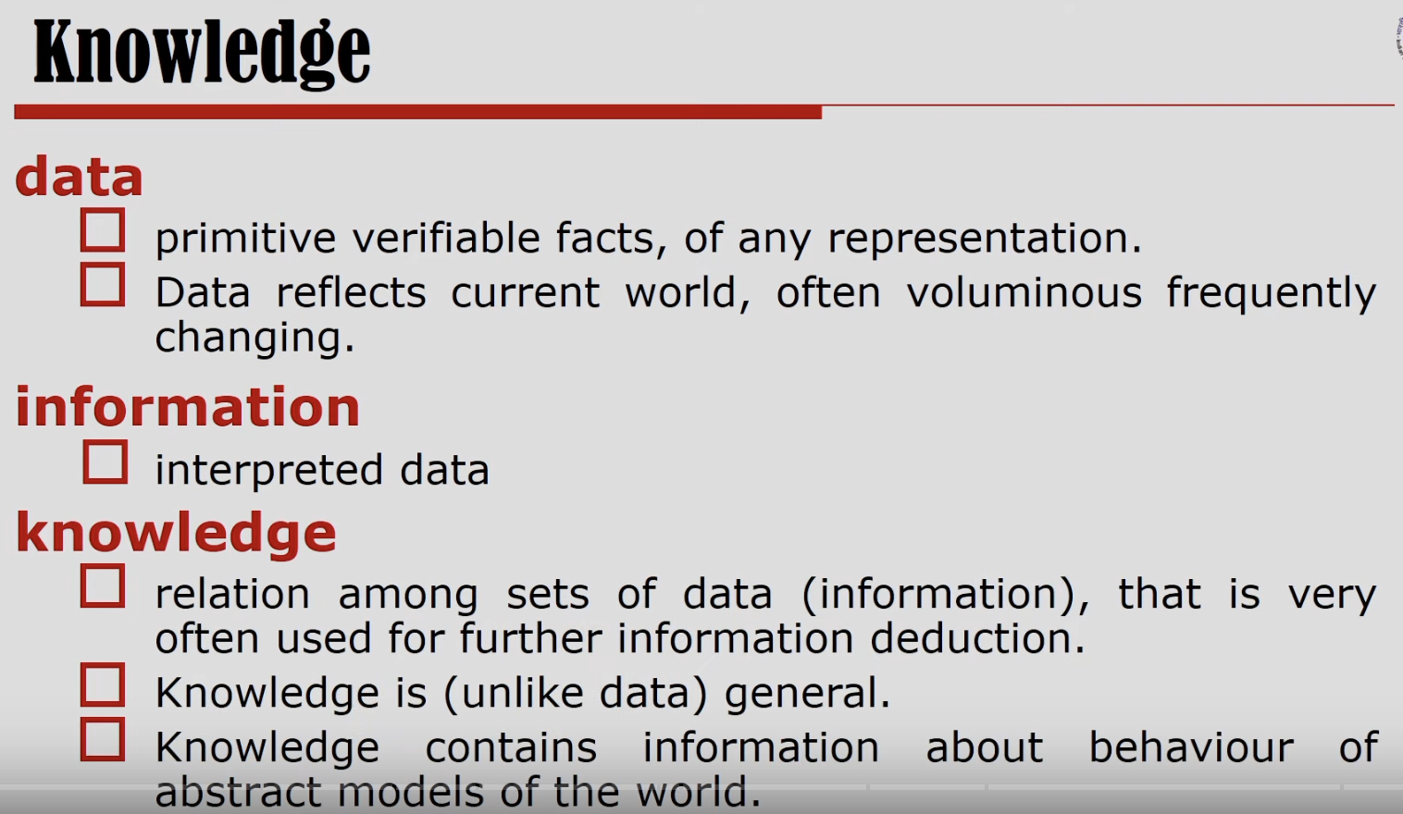

As we process the data, we will get information.

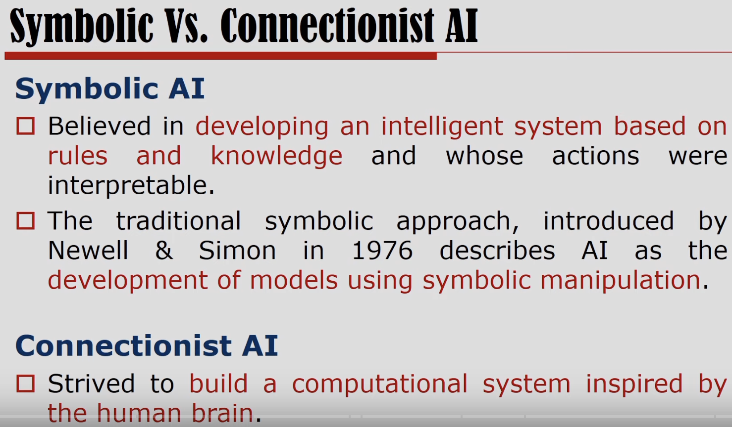

Both are essential

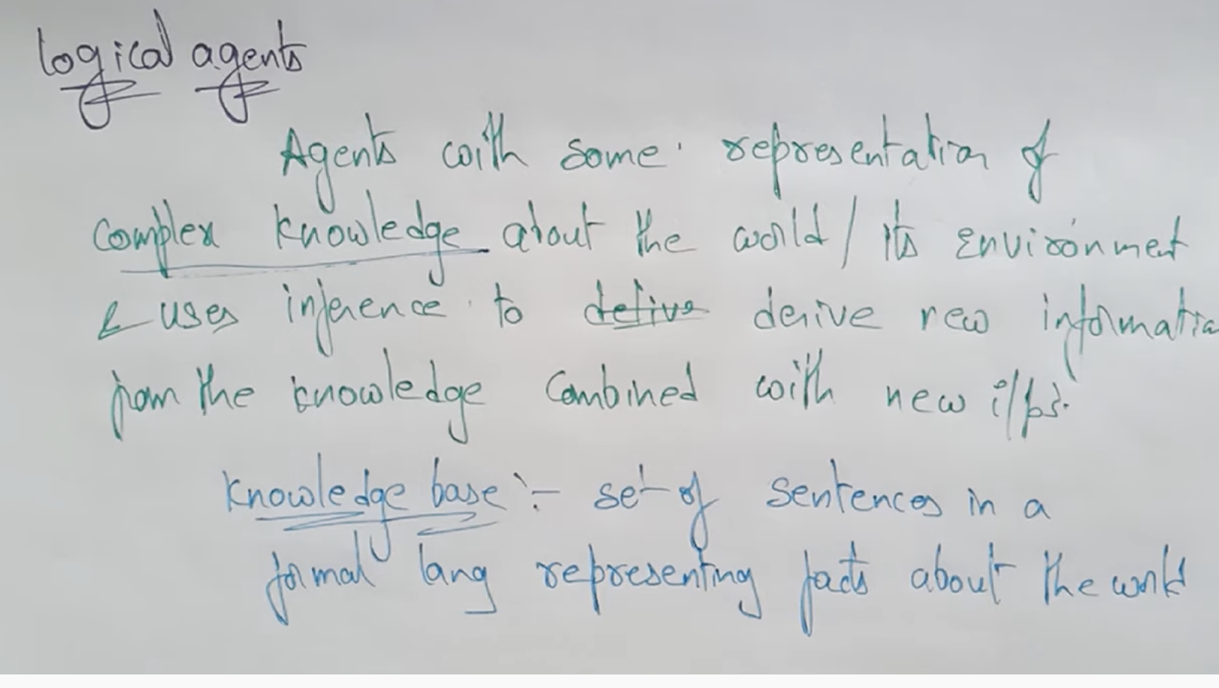

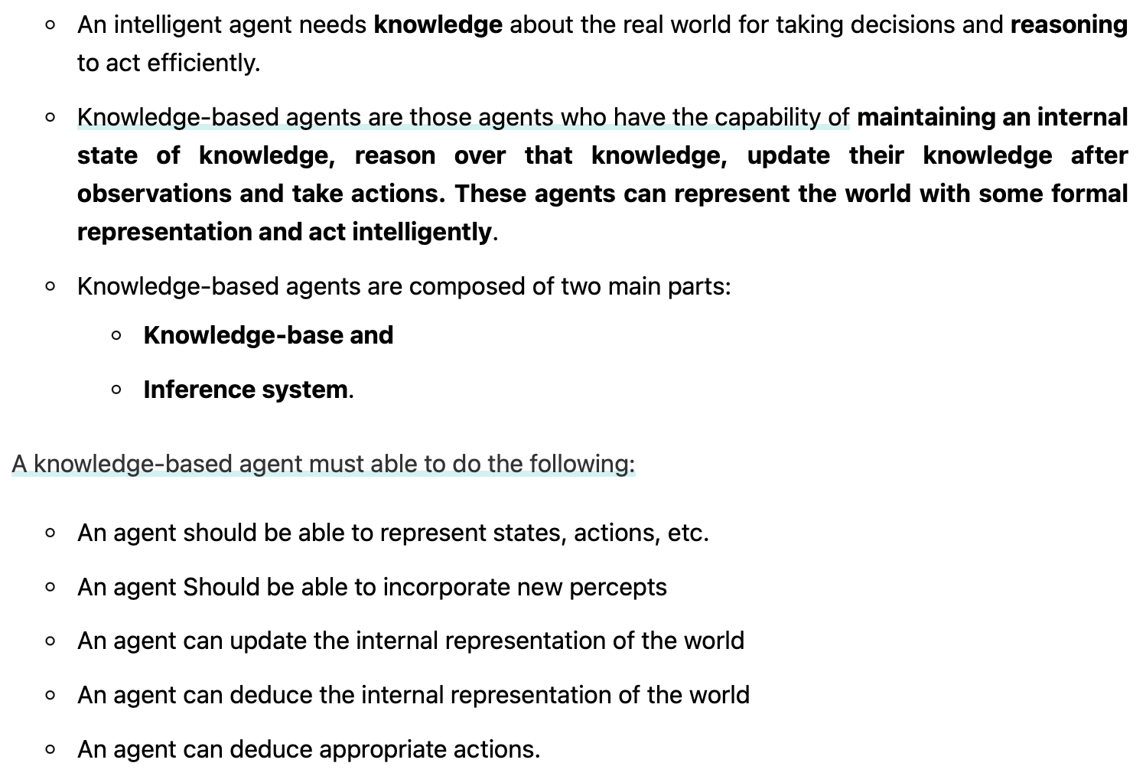

# **Knowledge Based Agent**

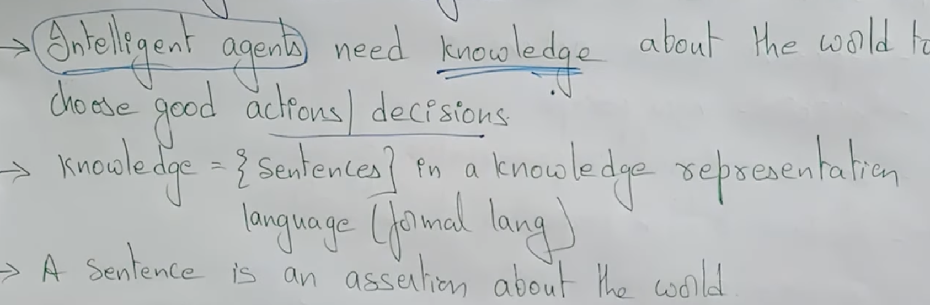

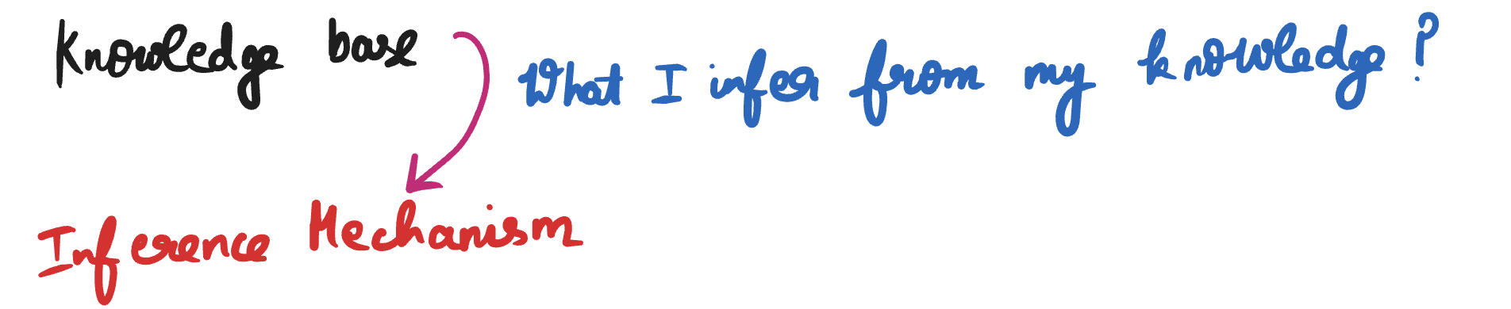

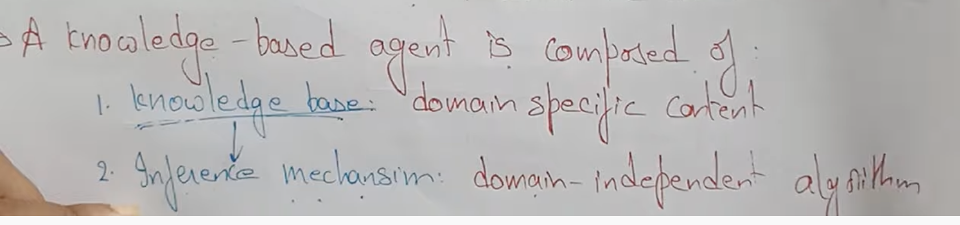

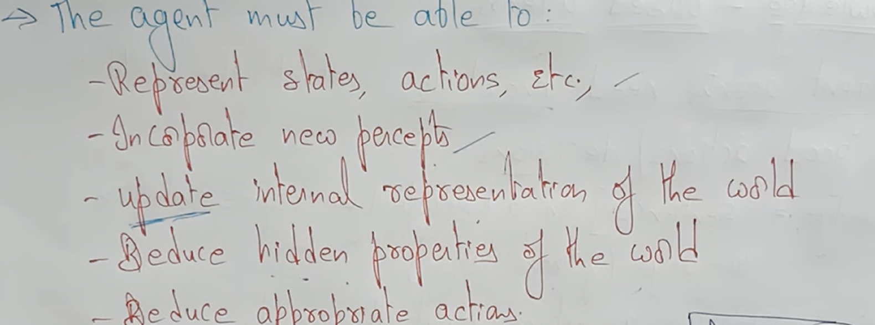

## **Architecture**

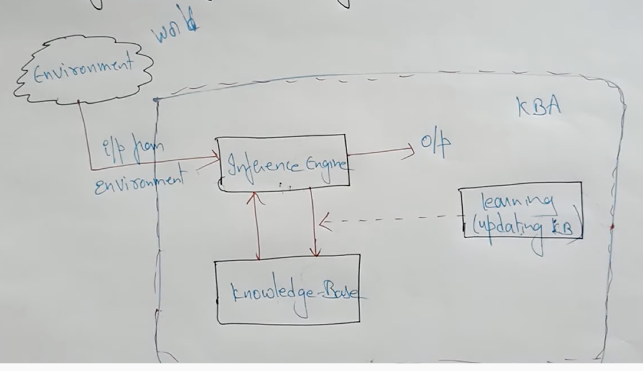

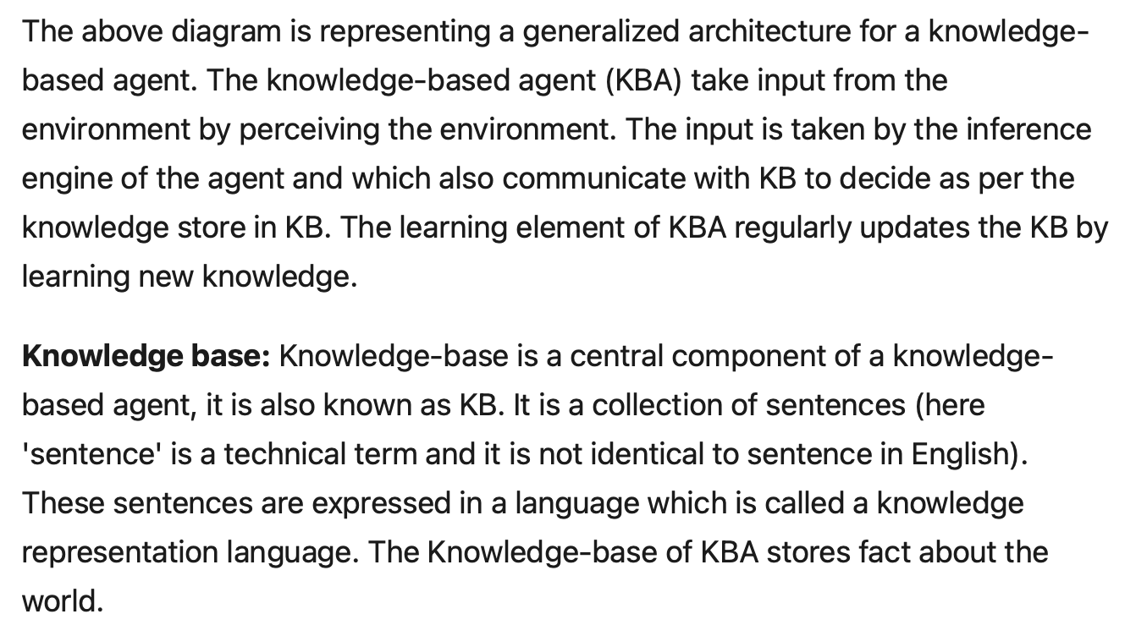

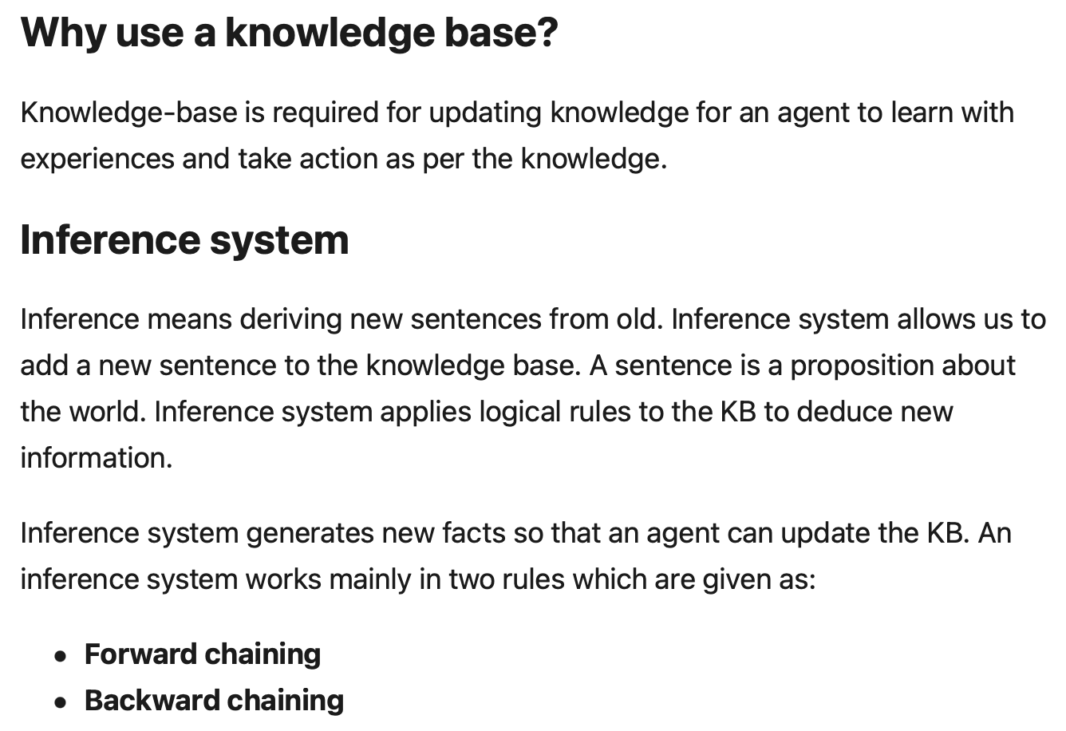

## **Approaches to Design a Knowledge-based agent**

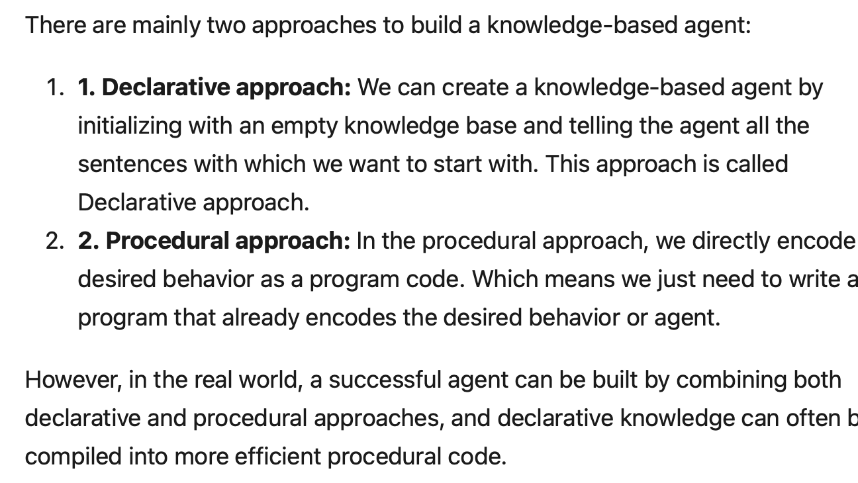

# **Techniques of Knowledge Representation**

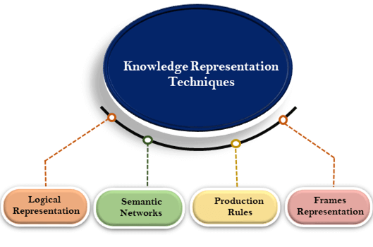

### **Propositional logic**

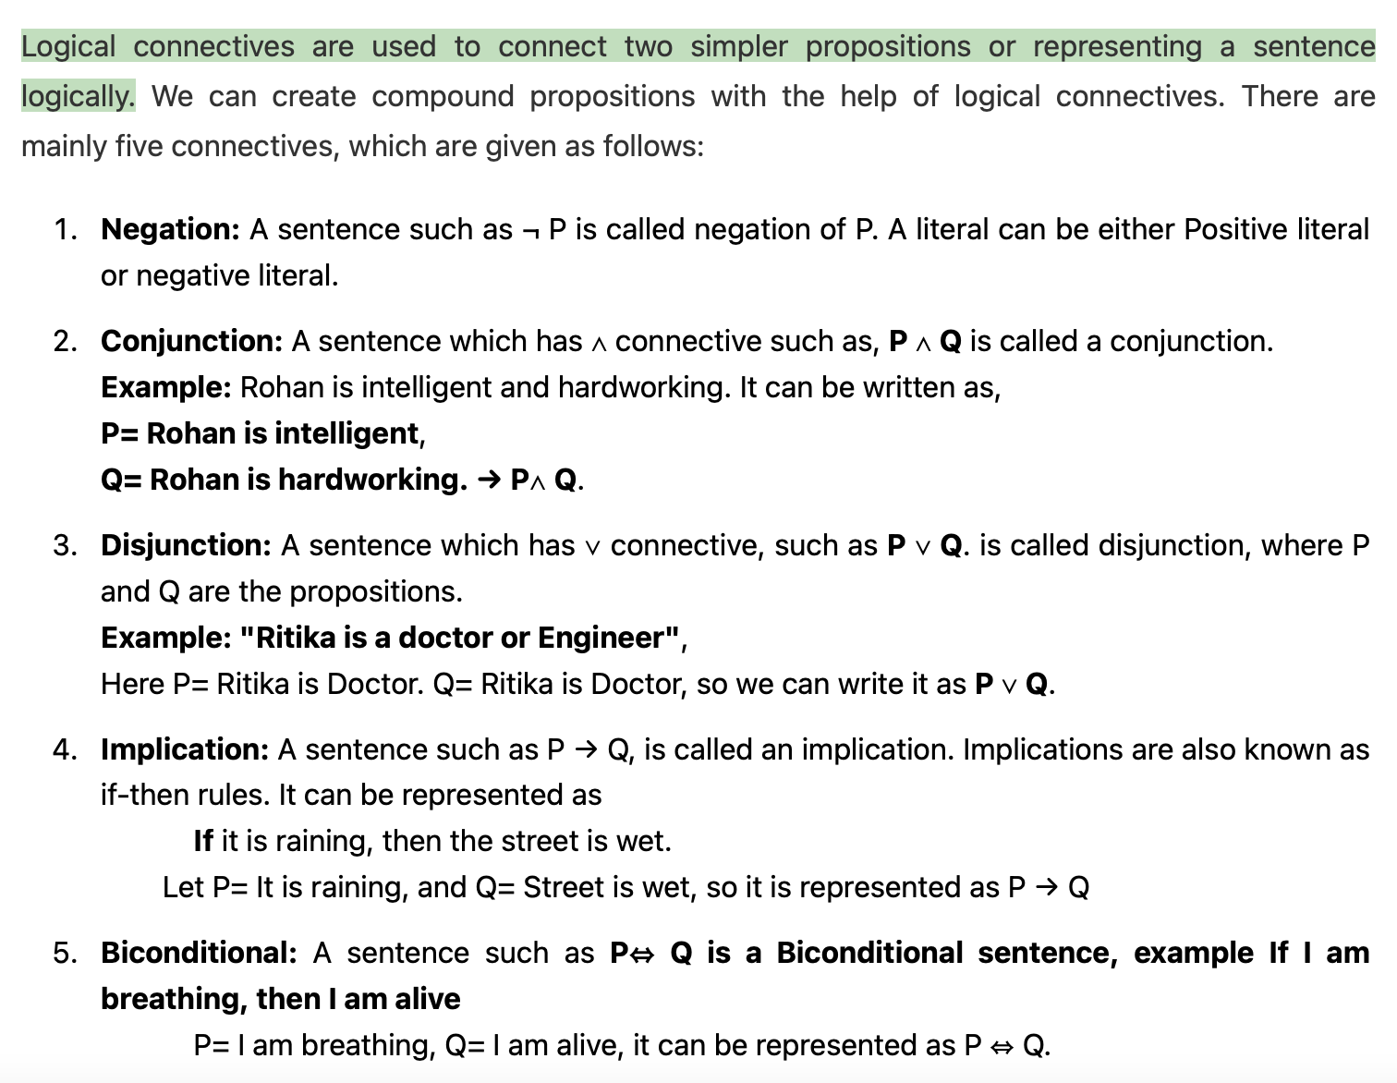

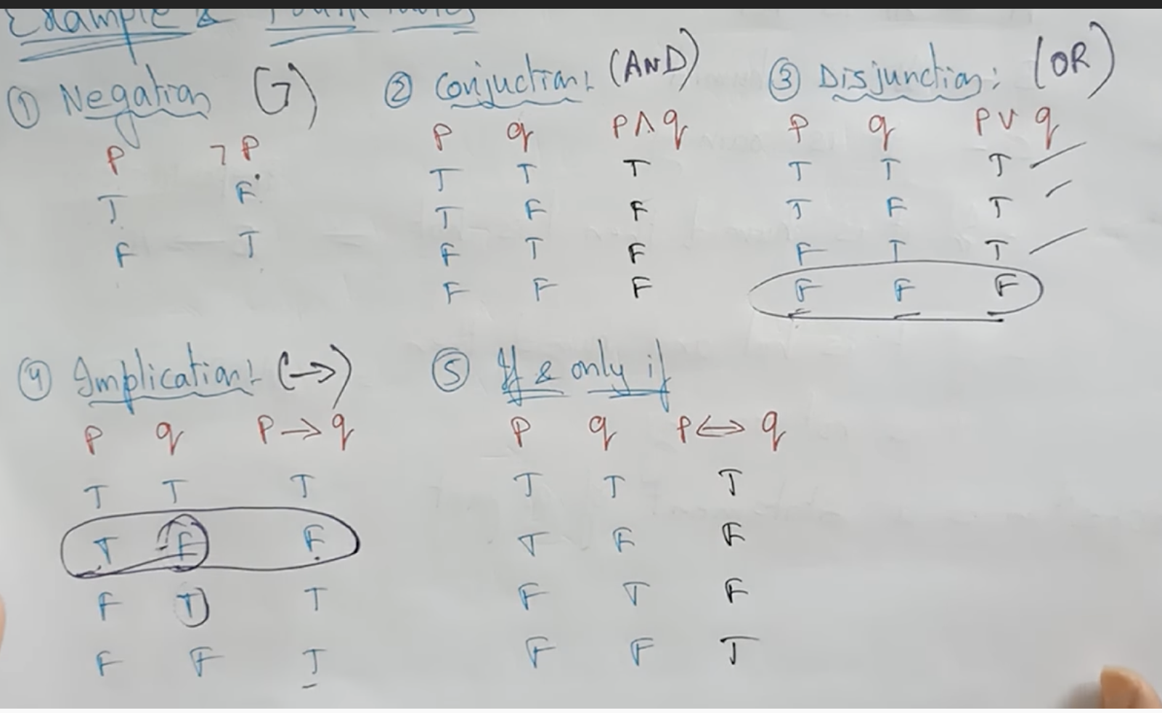

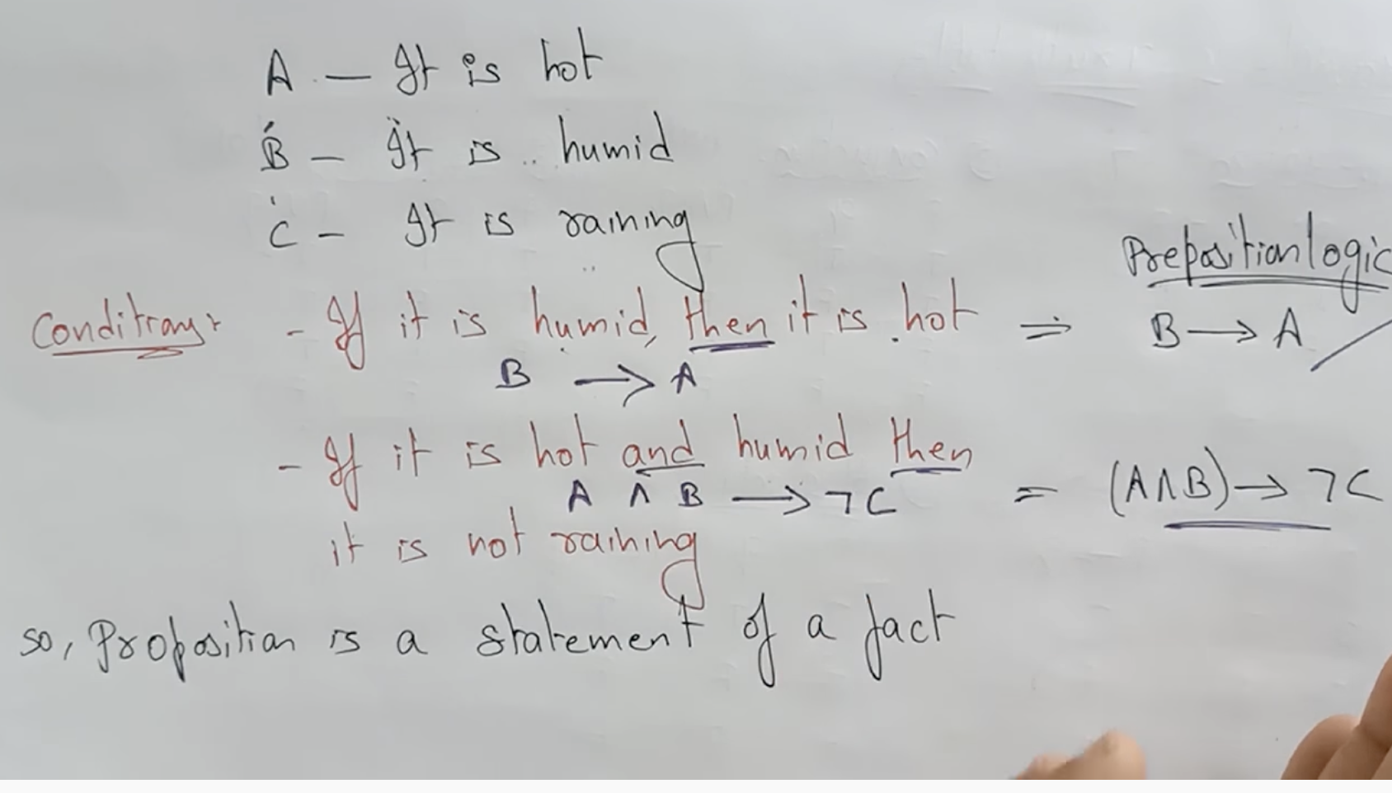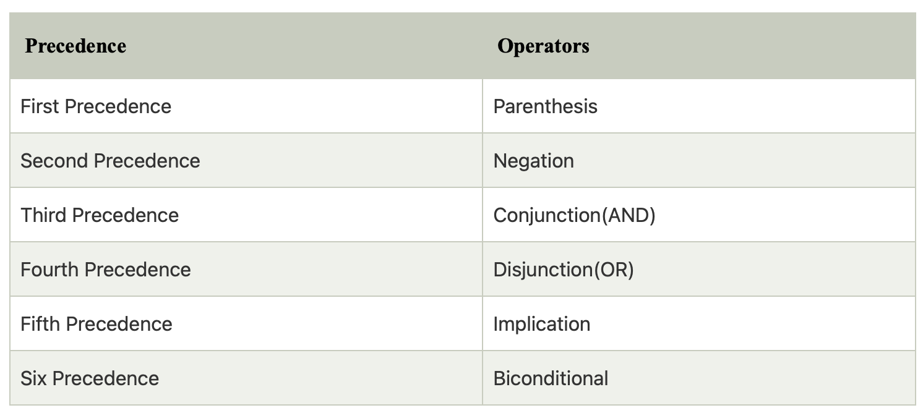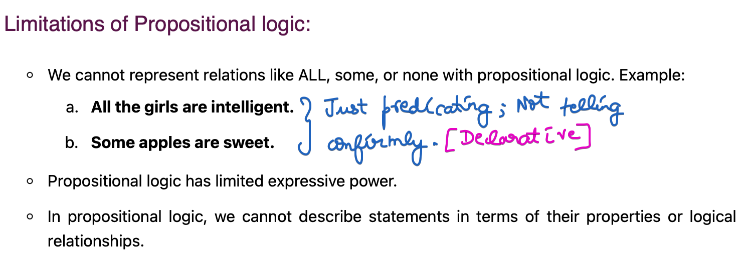

### **Eg: Wumpus World Problem**

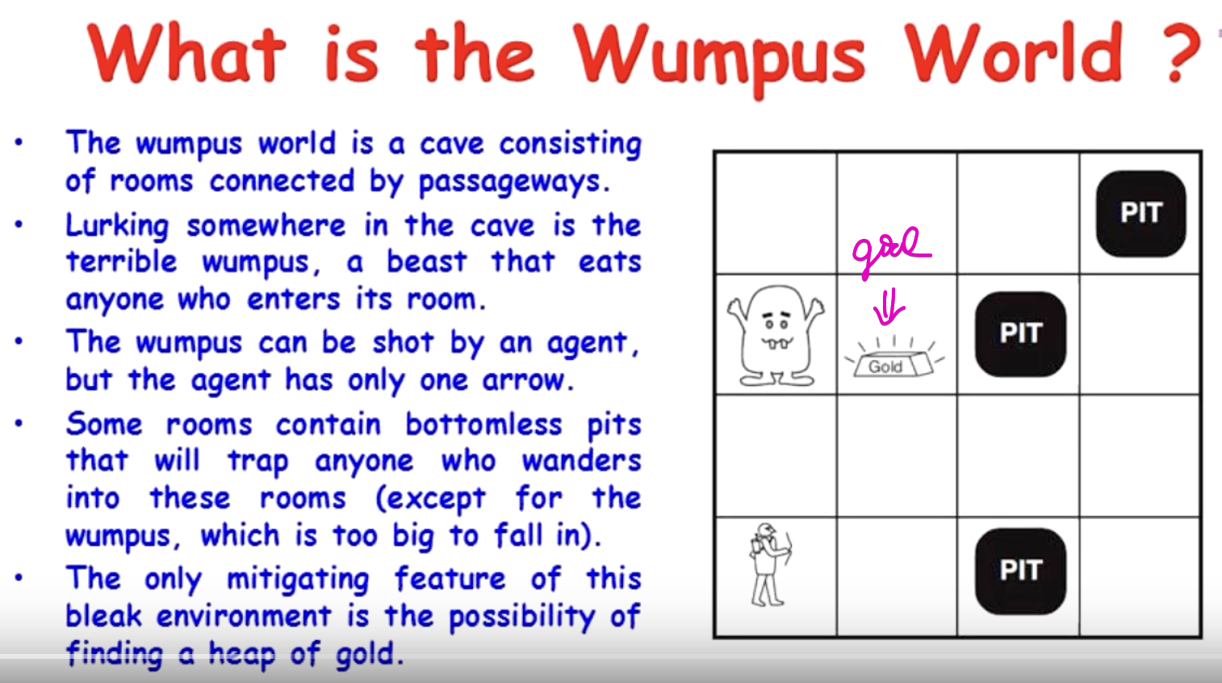

AIM 🡪 Agent must capture the Gold and should come out of the cave.

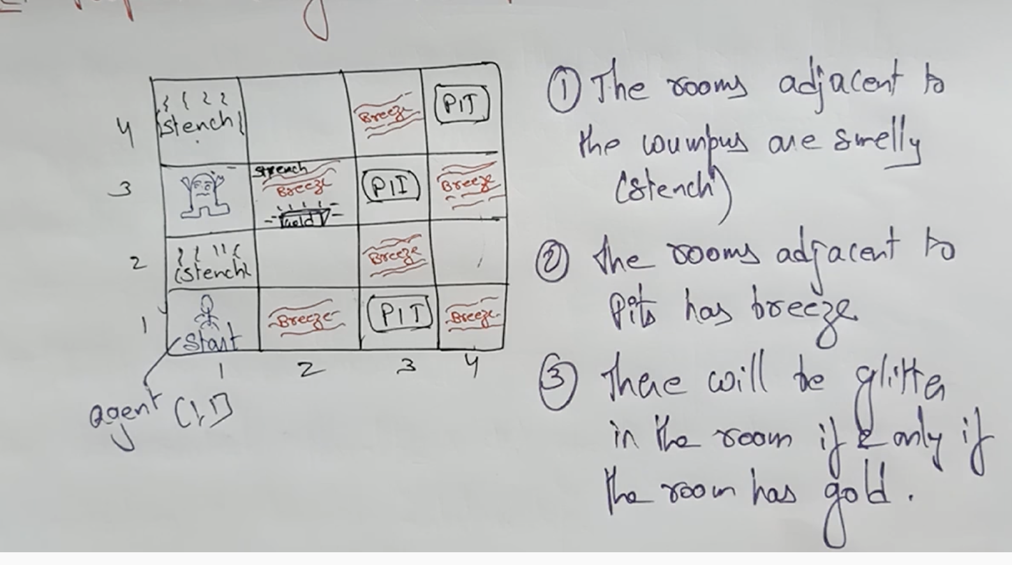

The Wumpus will be emitting a horrible scream. With the scream, the agent will start Agent can able to know where the Wumpus resides.

Actuators 🡪 left move, right move, capture, release.  
Sensors 🡪 stench smell, breeze, glitter, scream from wumpus.

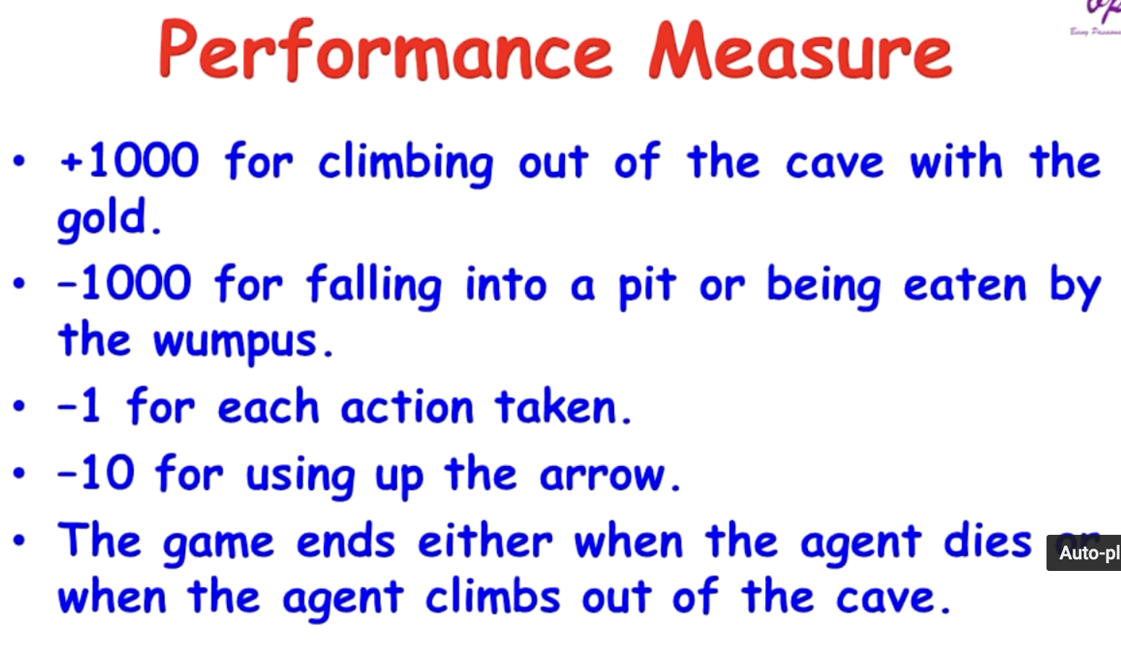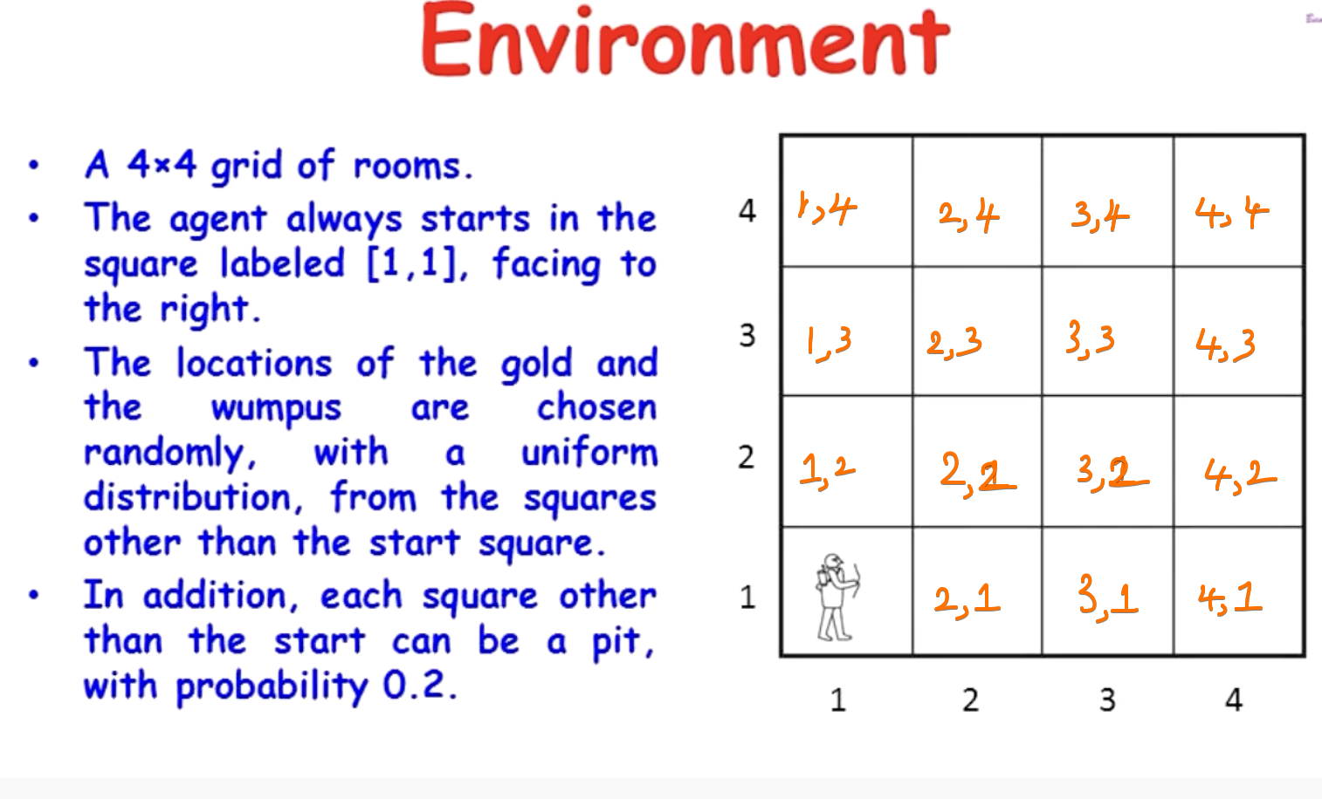

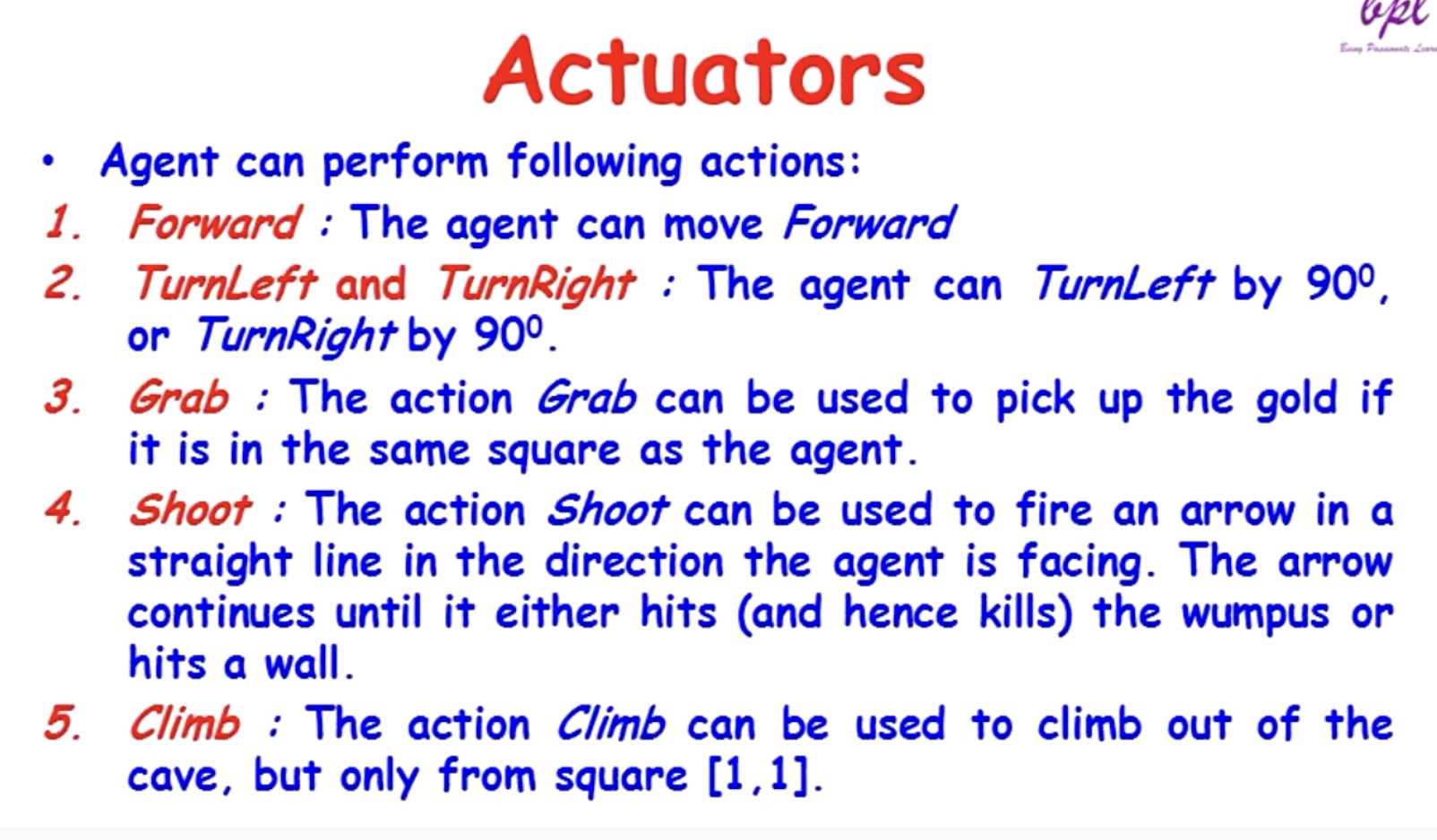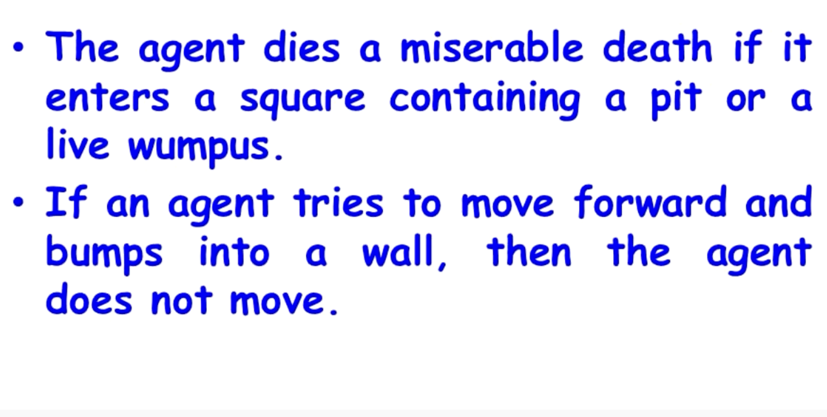

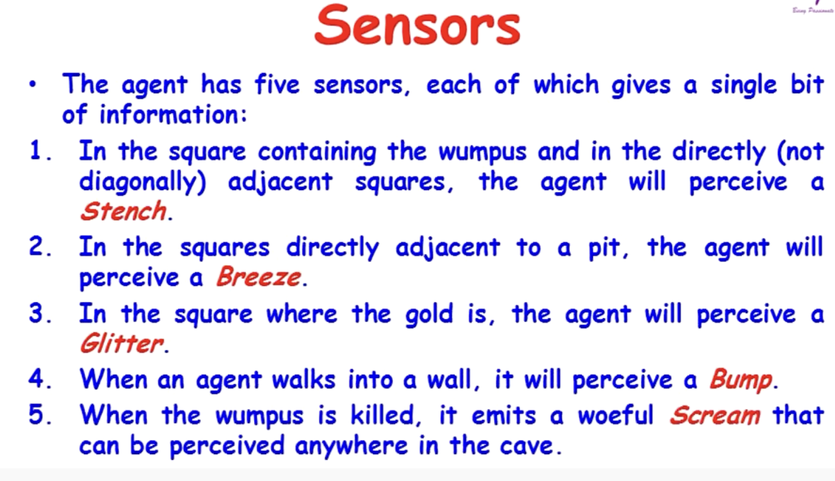

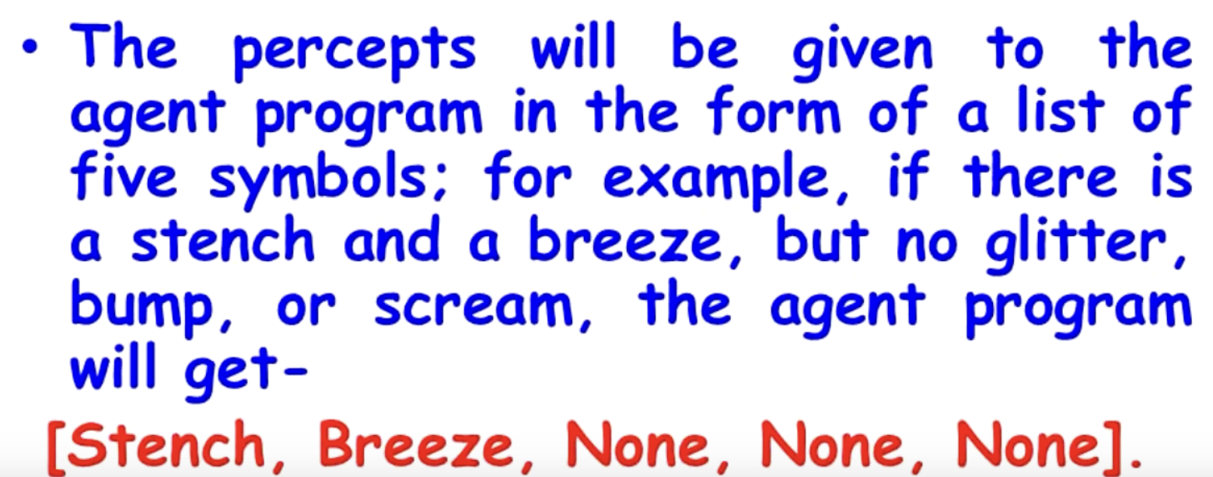

Agent will move only in ‘OK’ condition.

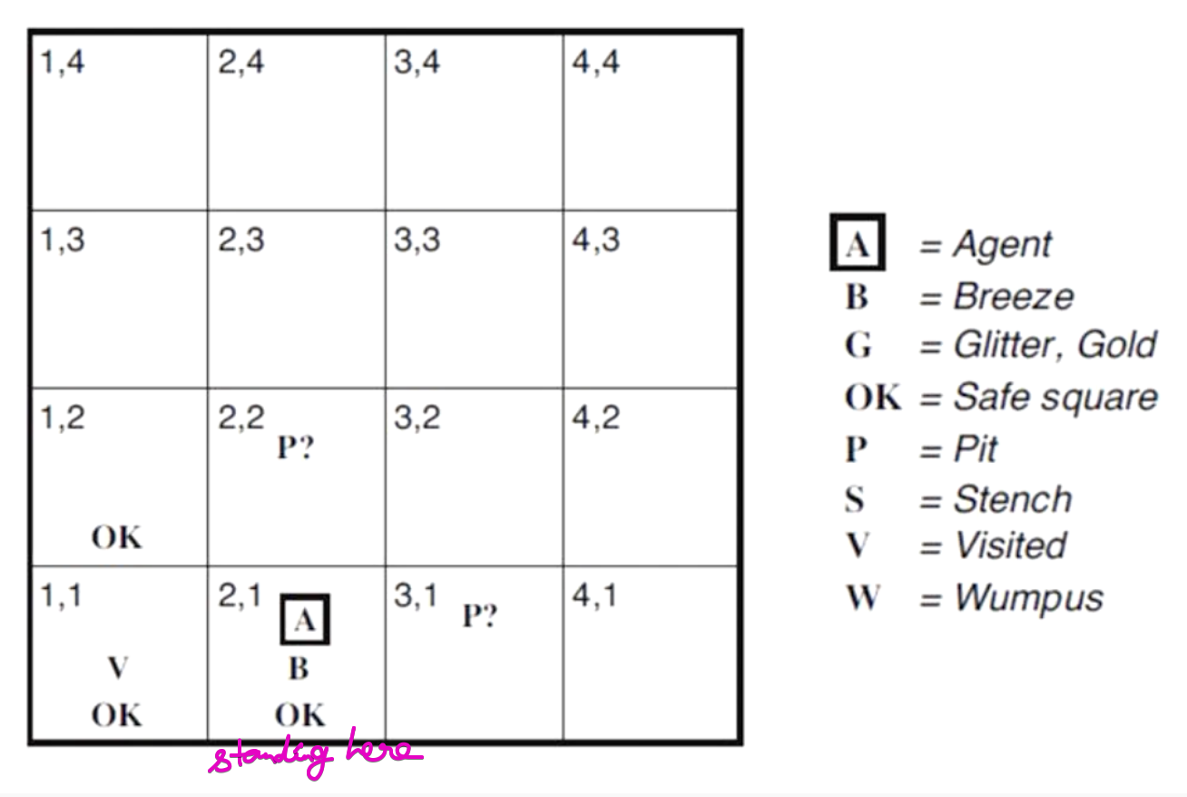  
Now in [2,1] (breeze) So the rooms adjacent to the PIT are breeze.  
So Standing in breeze, the agent suspects there are some PIT’s nearby.  
Without taking any risk, returning back.

Now the only option is to go to [1,2] position.

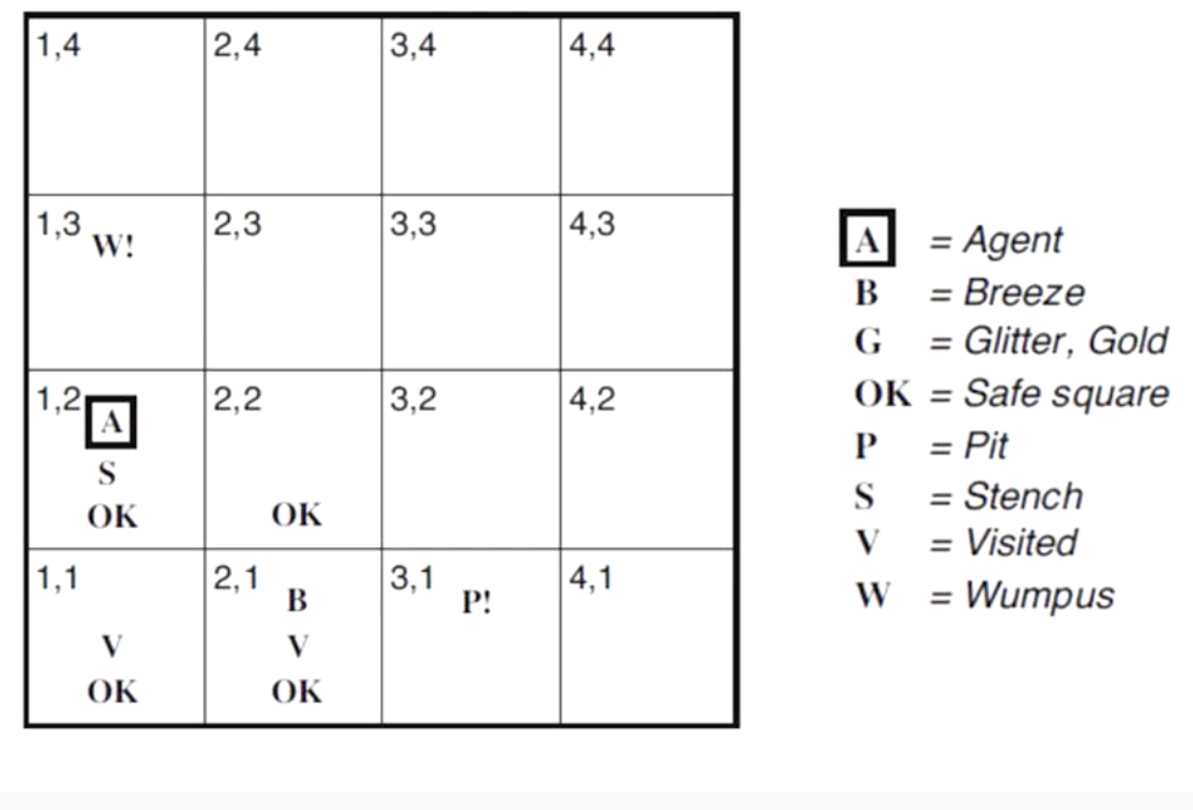

Now in [1,2] (stench), the agent is facing up-ward and saw the Wumpus. So, the agent goes to [2,2] (Since No breeze, so no doubt of a PIT)

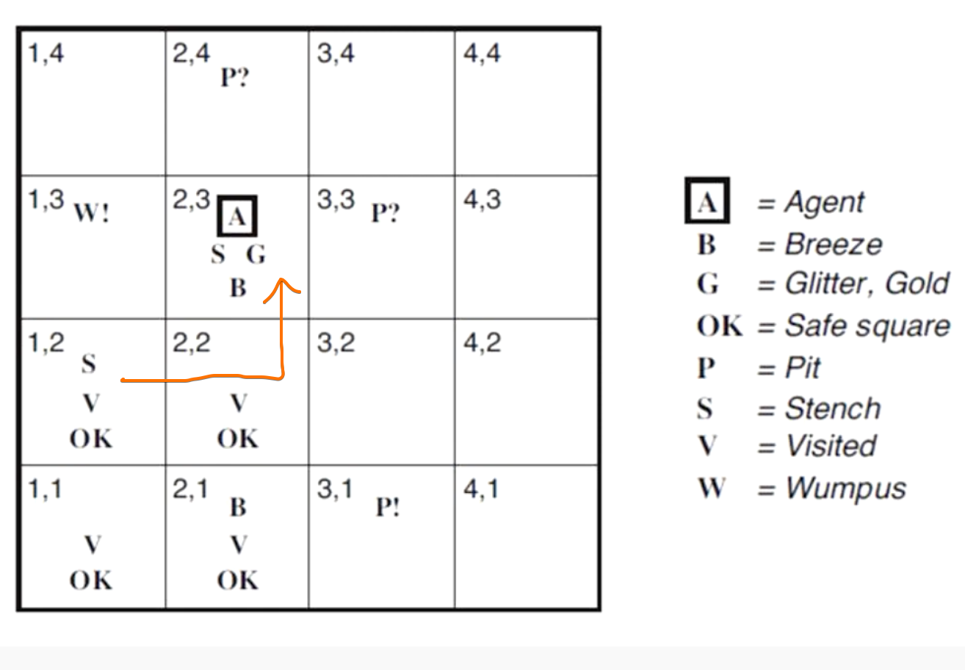

# **First Order Logic**

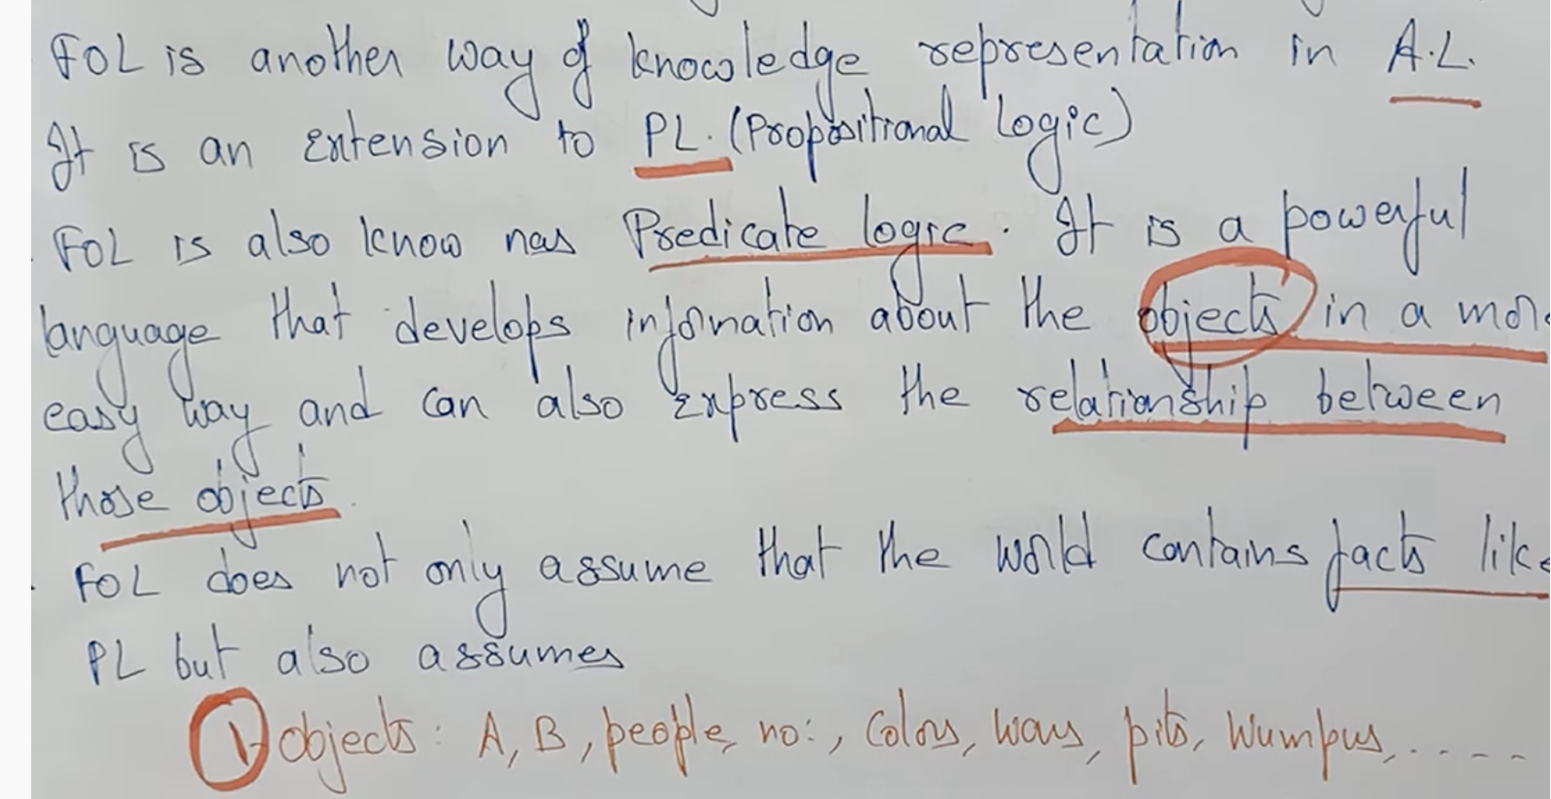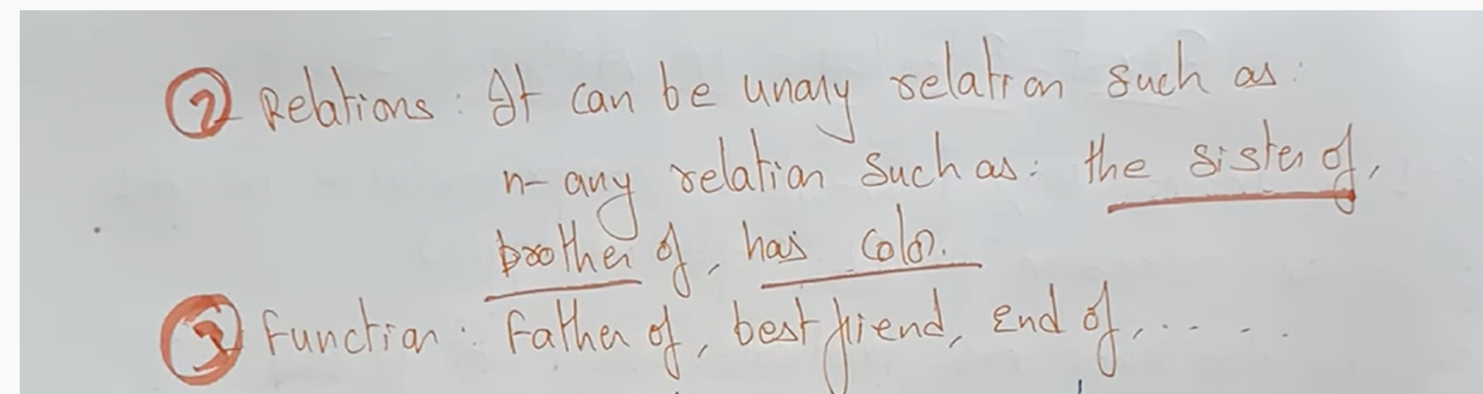

First Order Logic not only deals with the facts but  
also deals with Objects, Relations and Functions.

## **Syntax of FOL**

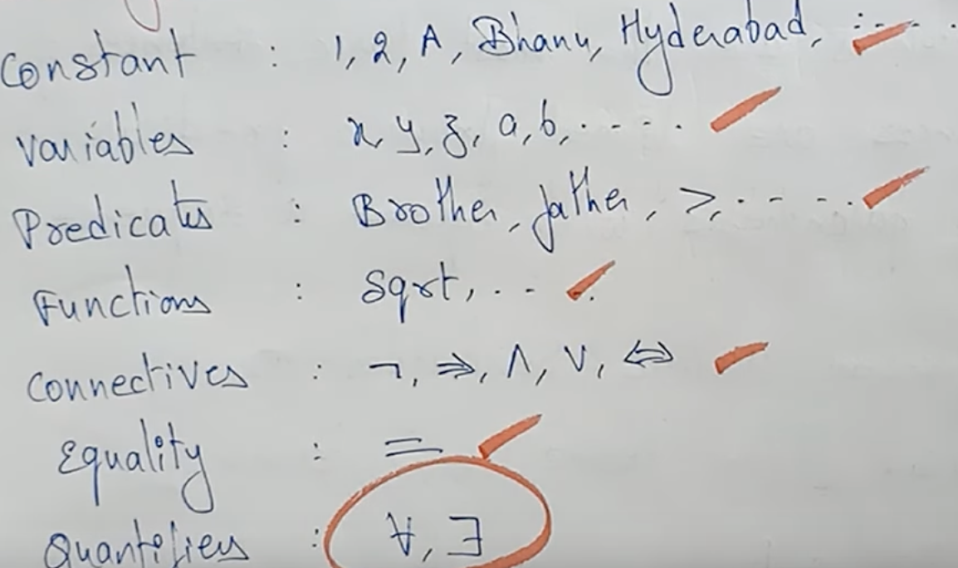

Quantifiers

## **Semantics of FOL**

# **Atomic Sentence**

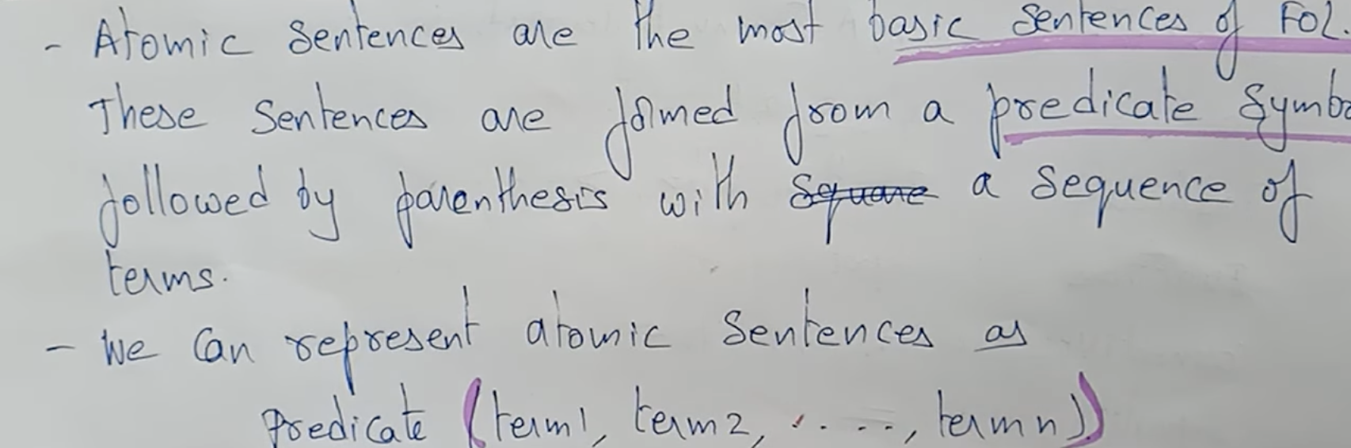  
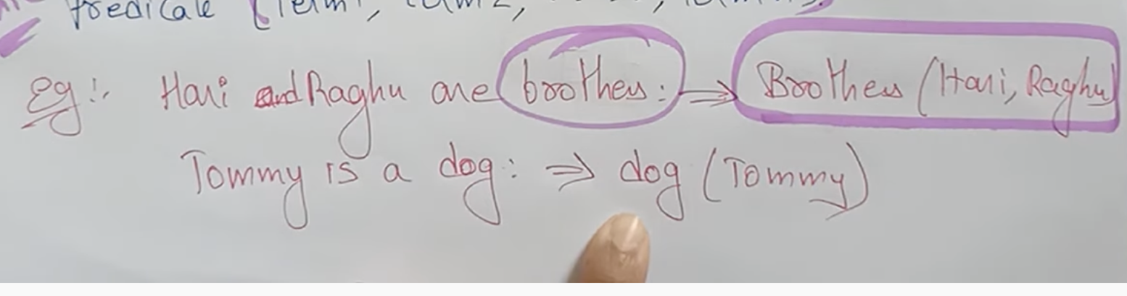

**

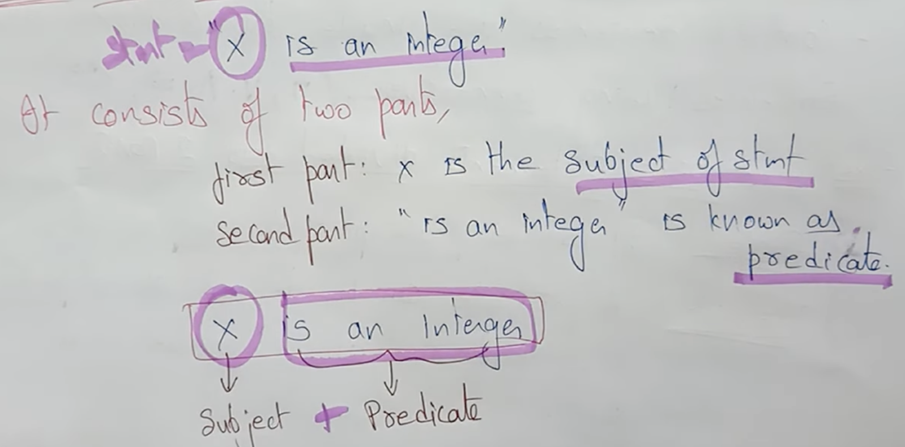

# **Quantifiers**

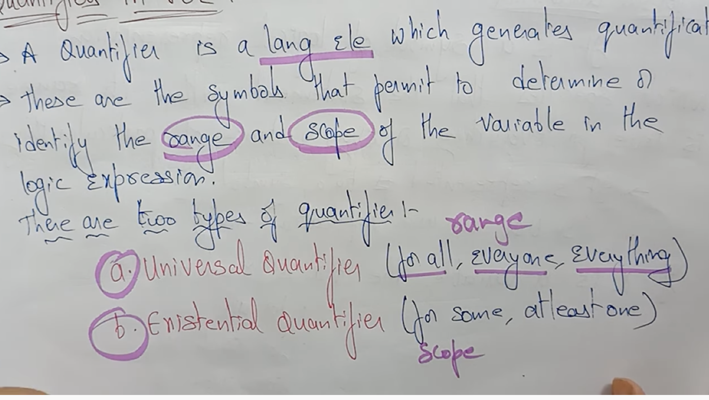

## **Universal Quantifier**

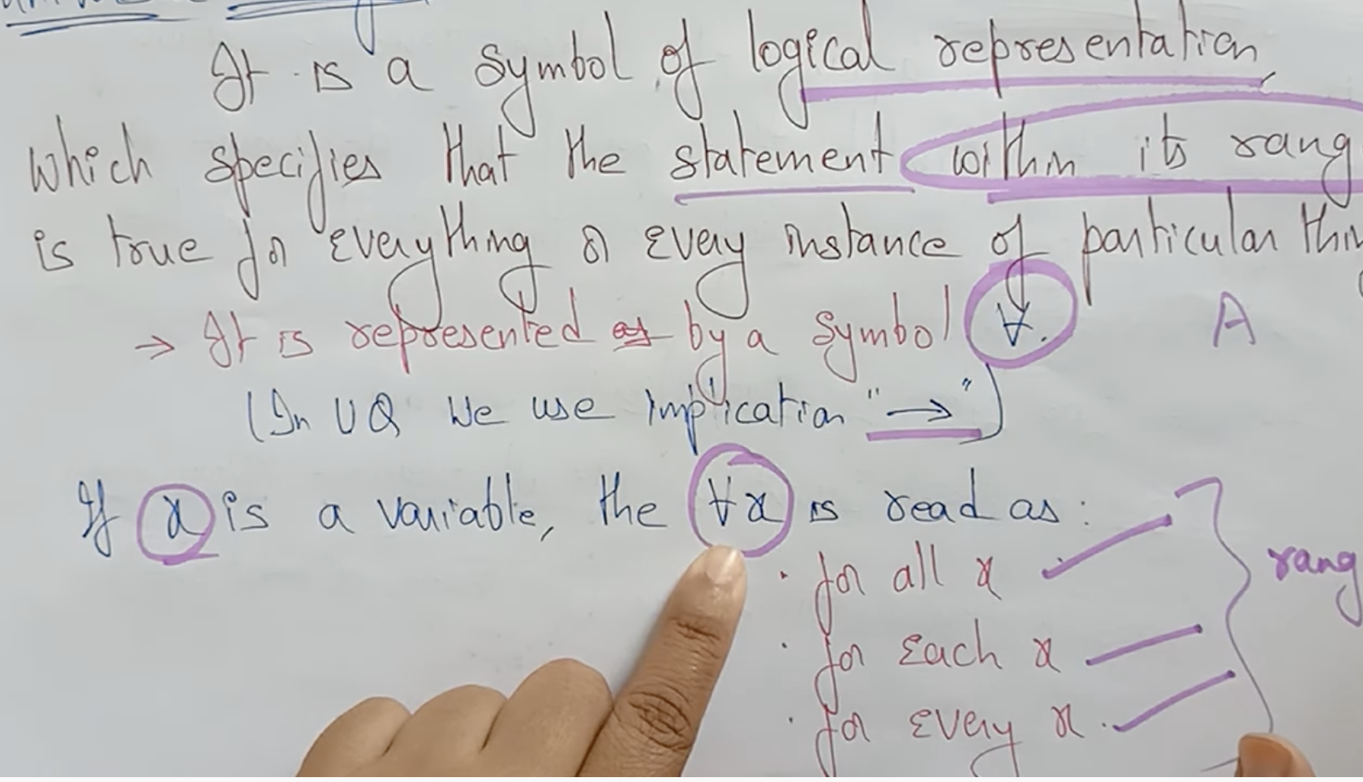

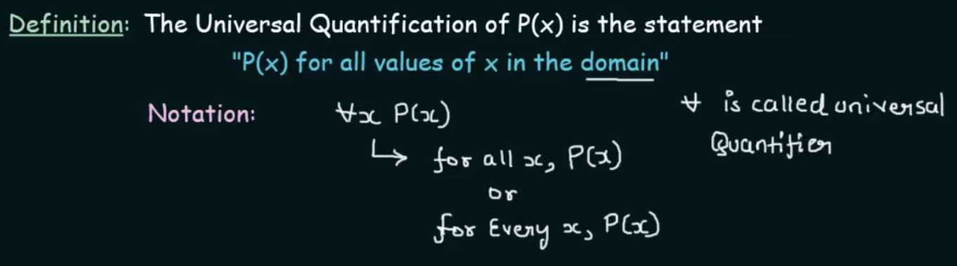

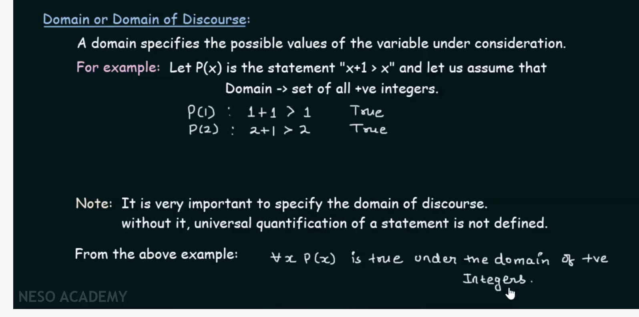

So domain is essential always.

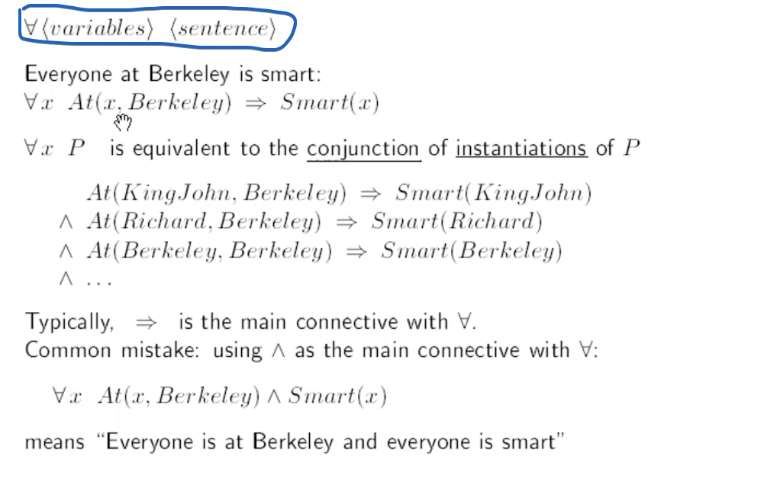

## **Existential Quantifier**

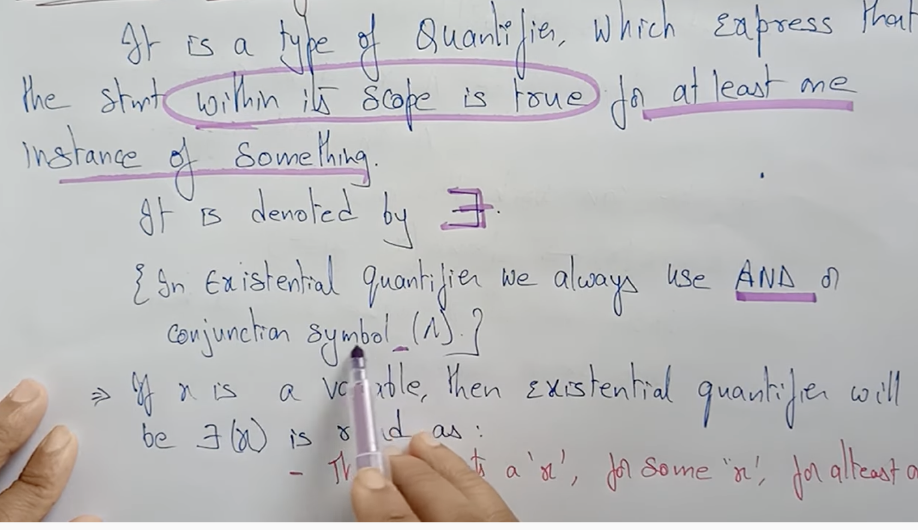

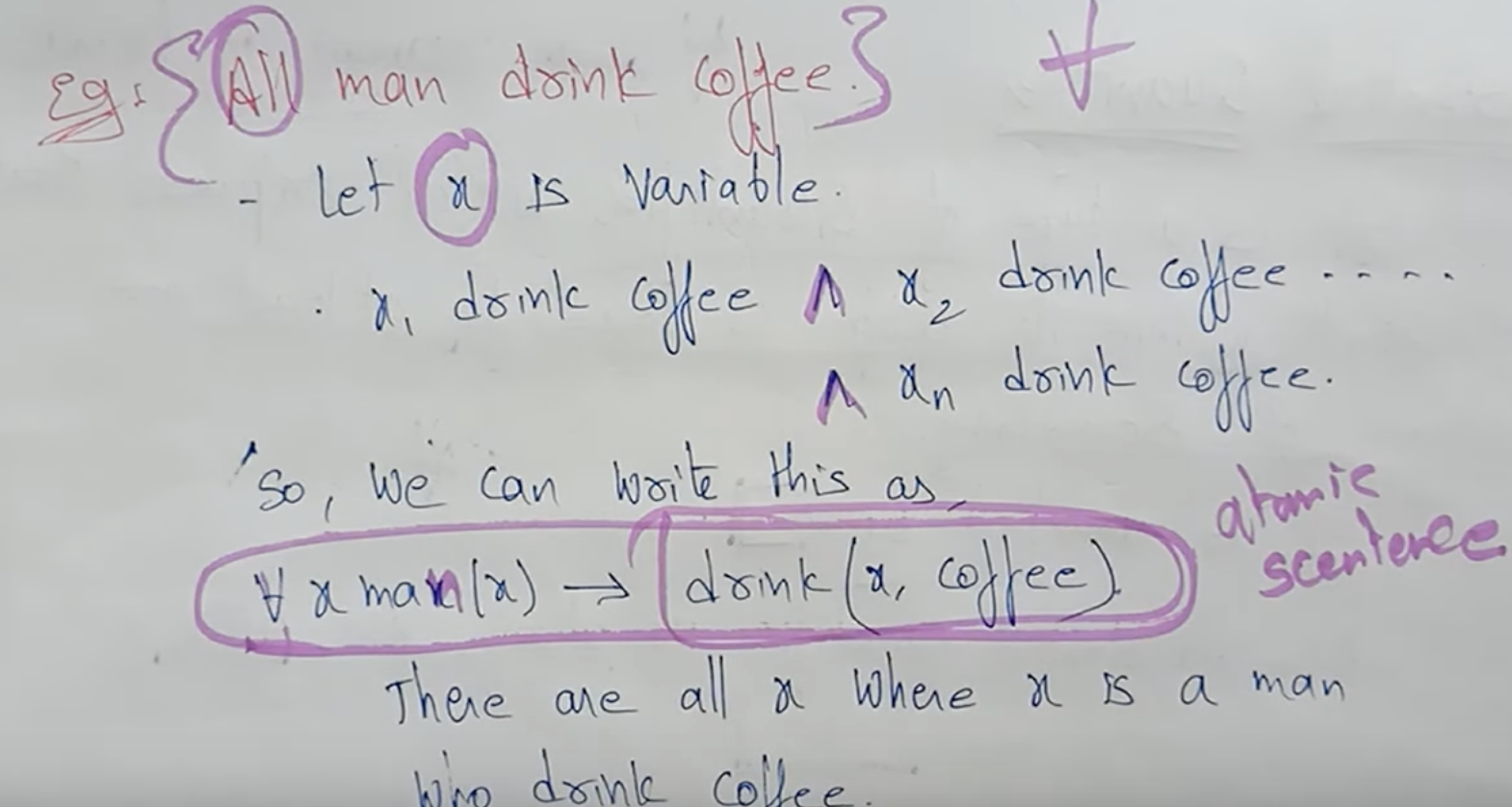

# **FOL using Quantifiers**

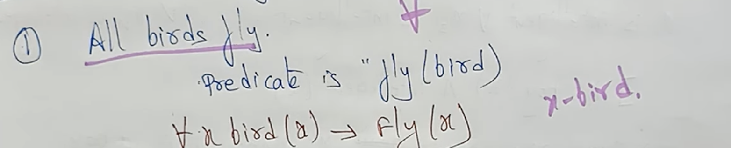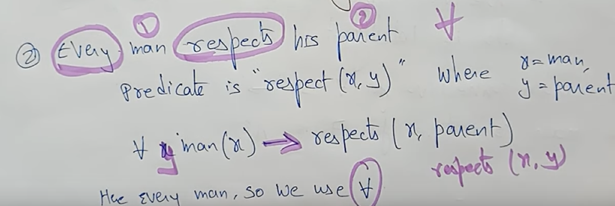

respects(x, parent) or respects(x, y)

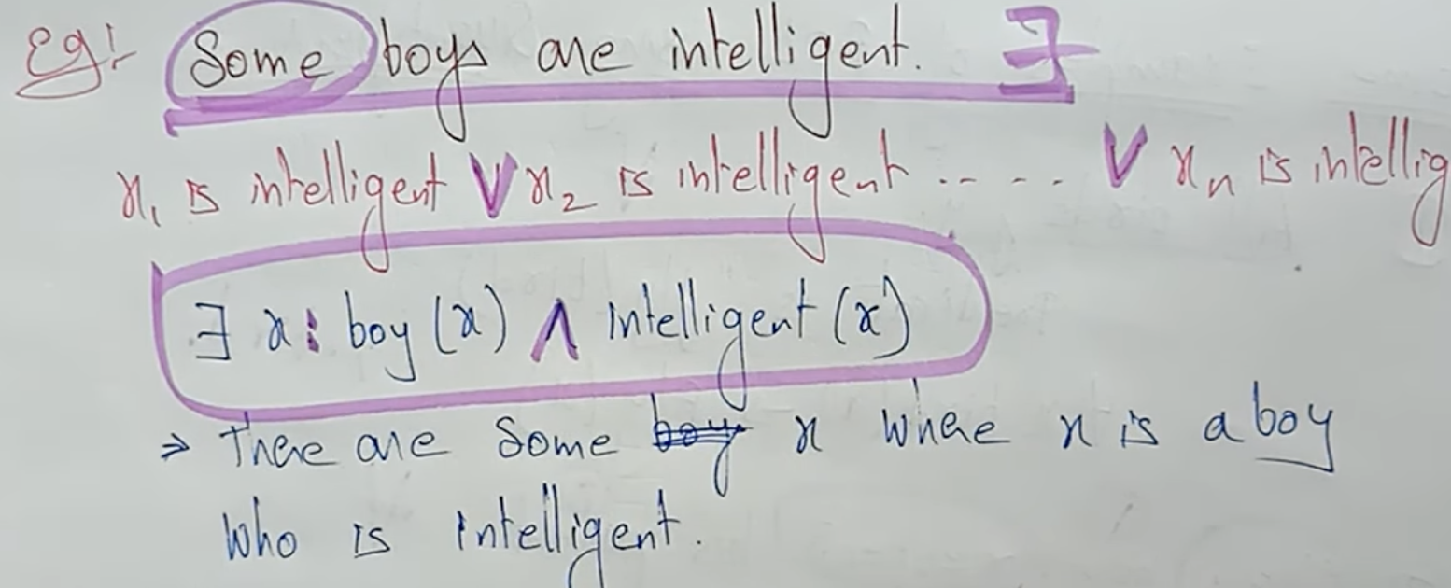

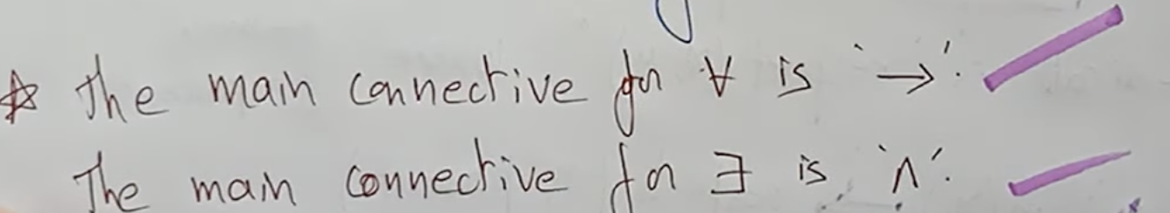

# **Inferences in FOL**

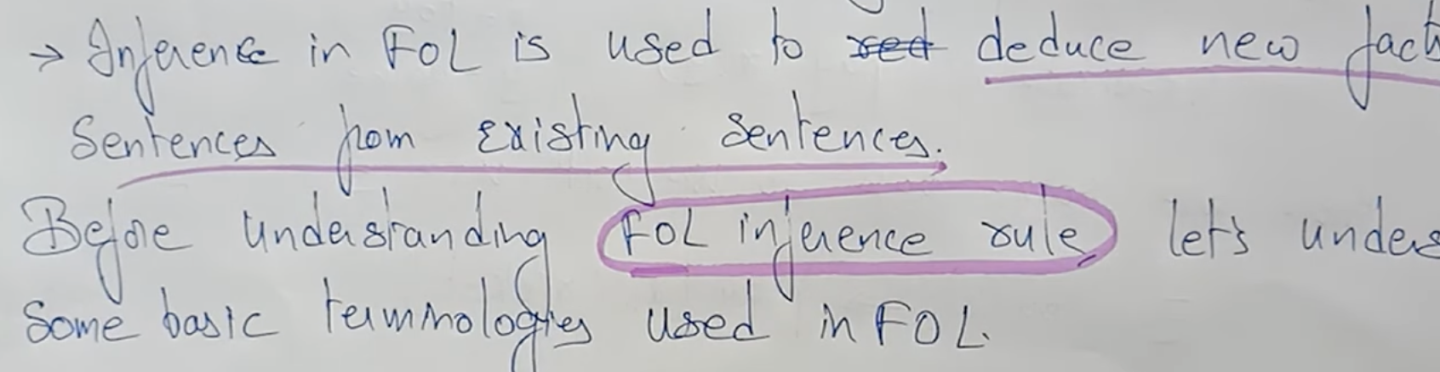

1. Substitution

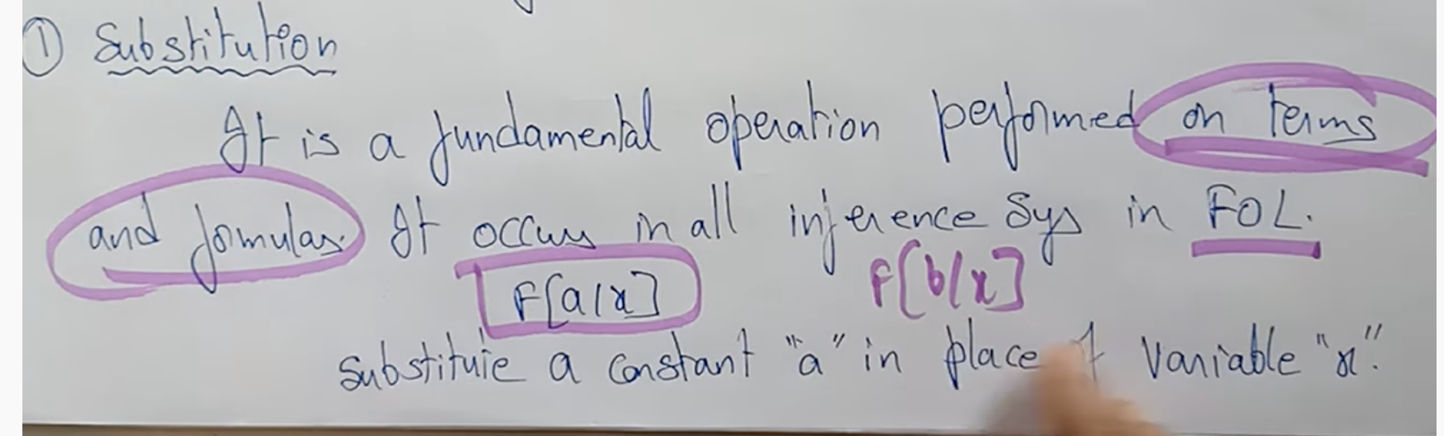

1. Equality

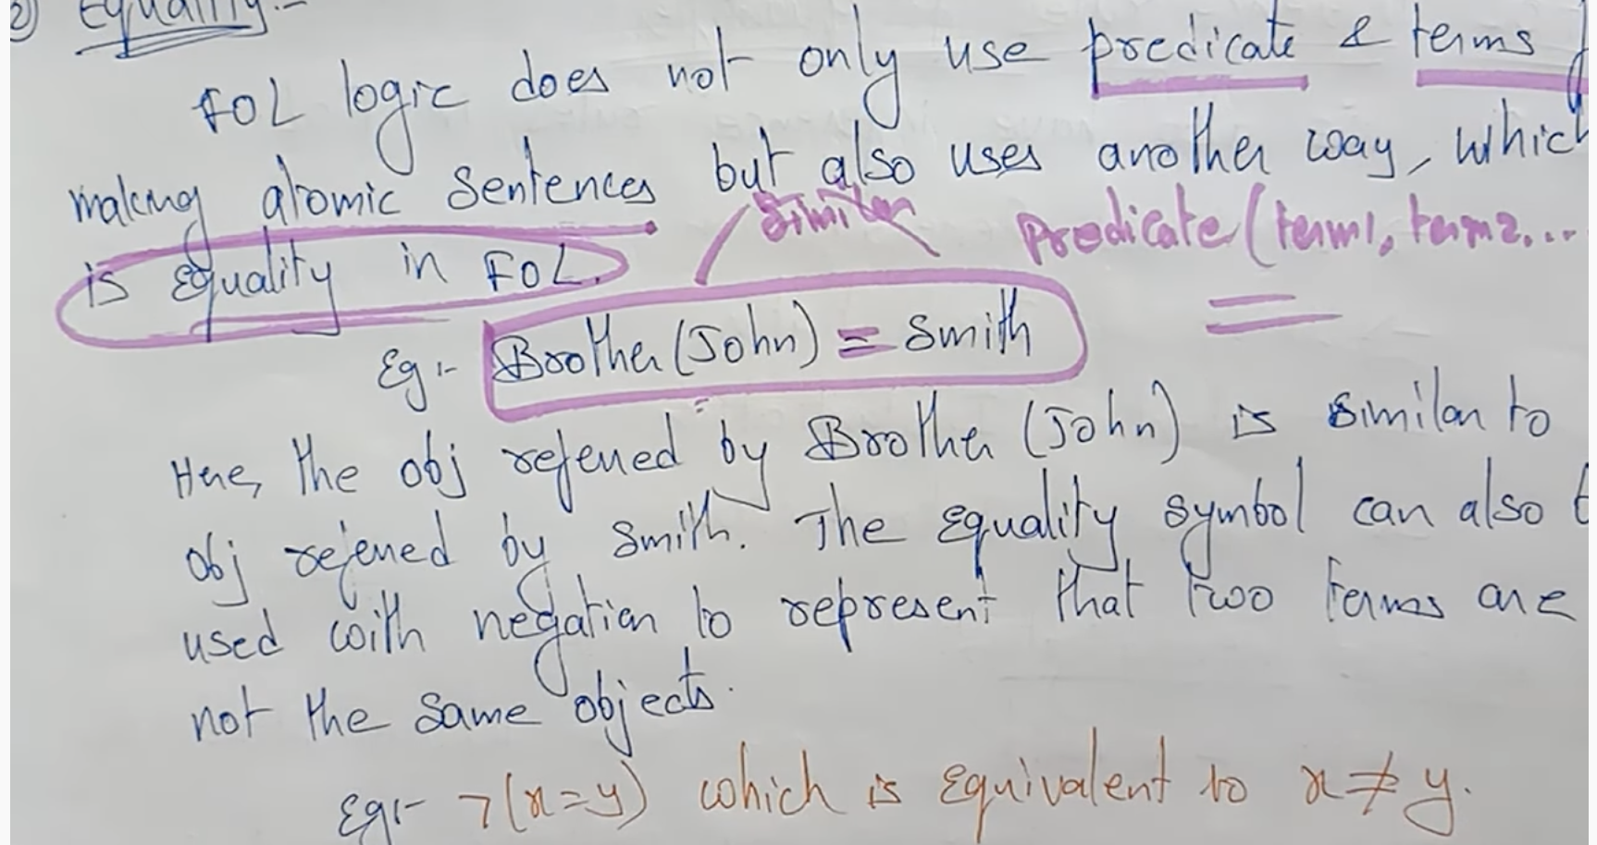

Equality 🡪 John is the brother of Smith. (or) Smith is the brother of John.

Not Equality 🡪 John is not the brother of Smith.

# **Inference rules for quantifiers**

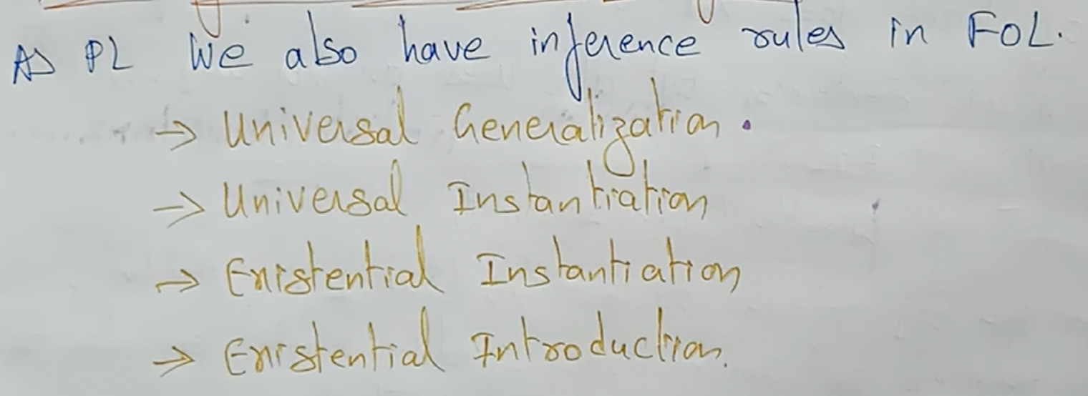

## **Universal Generalization**

It is a valid inference rule which states that if the “Premise P(C) is true for any arbitrary element C in the university of discourse, then we can have a conclusion as For all x P(x) “  
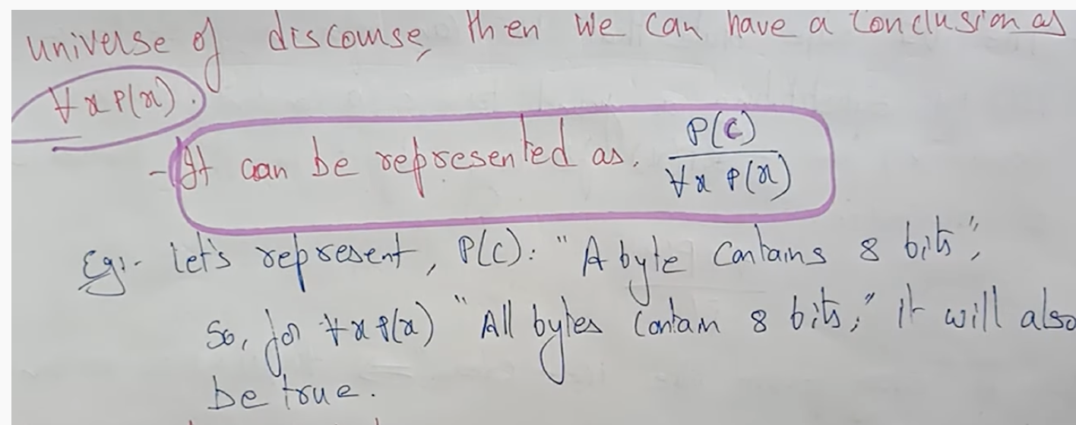

If a particular byte contains 8 bits means, then all bytes will contains 8 bits only.

## **Universal Instantiation (universal elimination)**

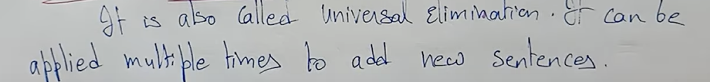

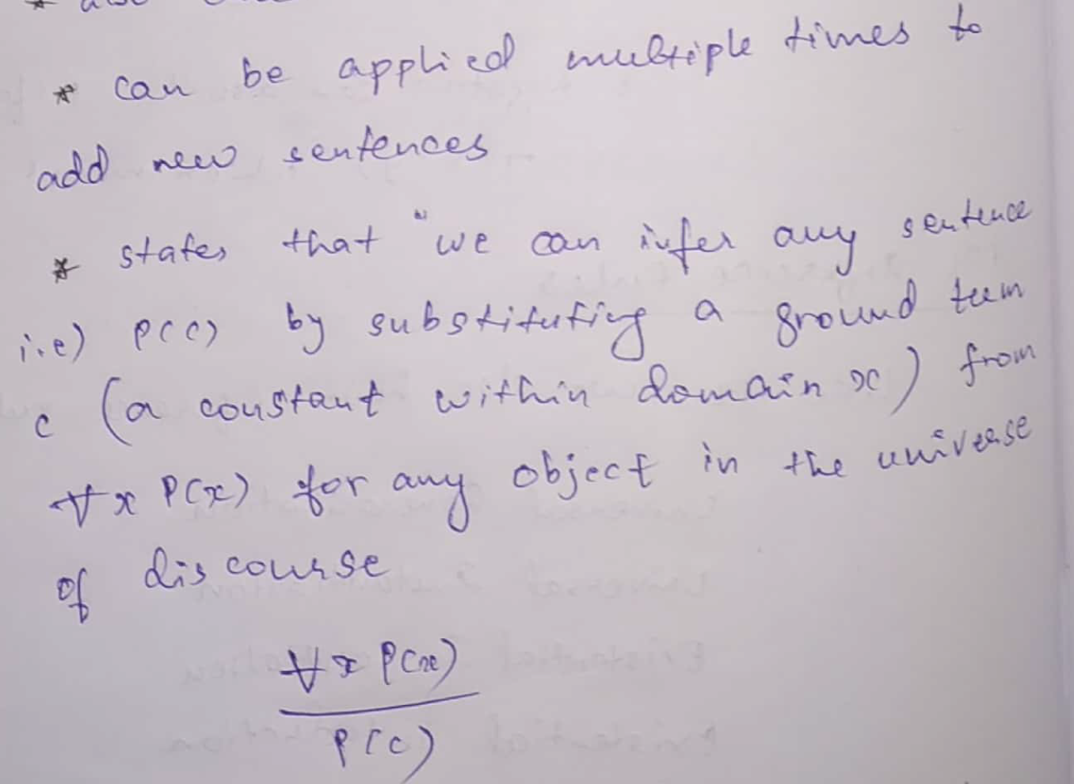

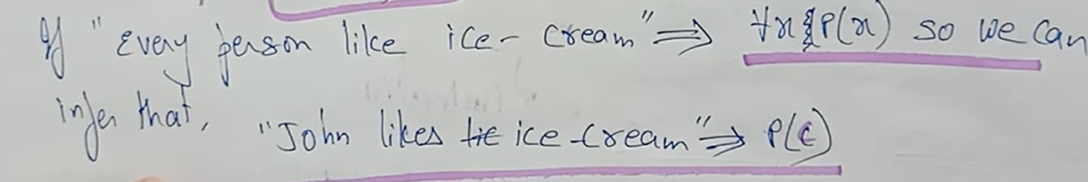

## **Existential Instantiation (existential elimination)**

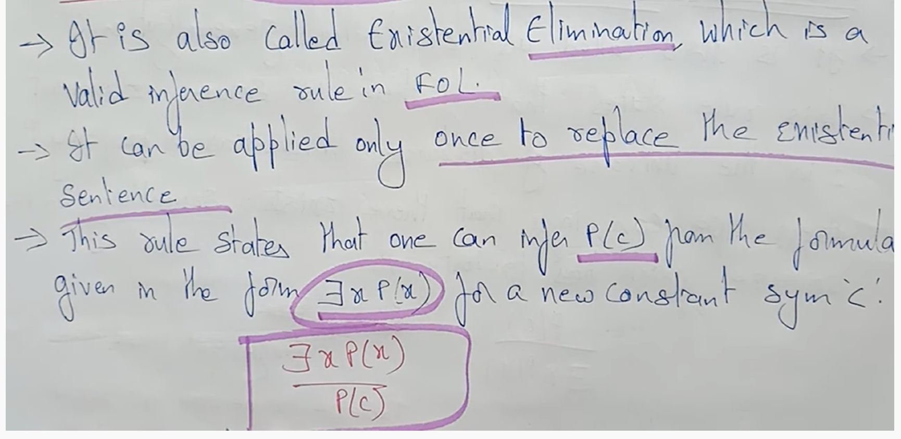

## **Existential Introduction**

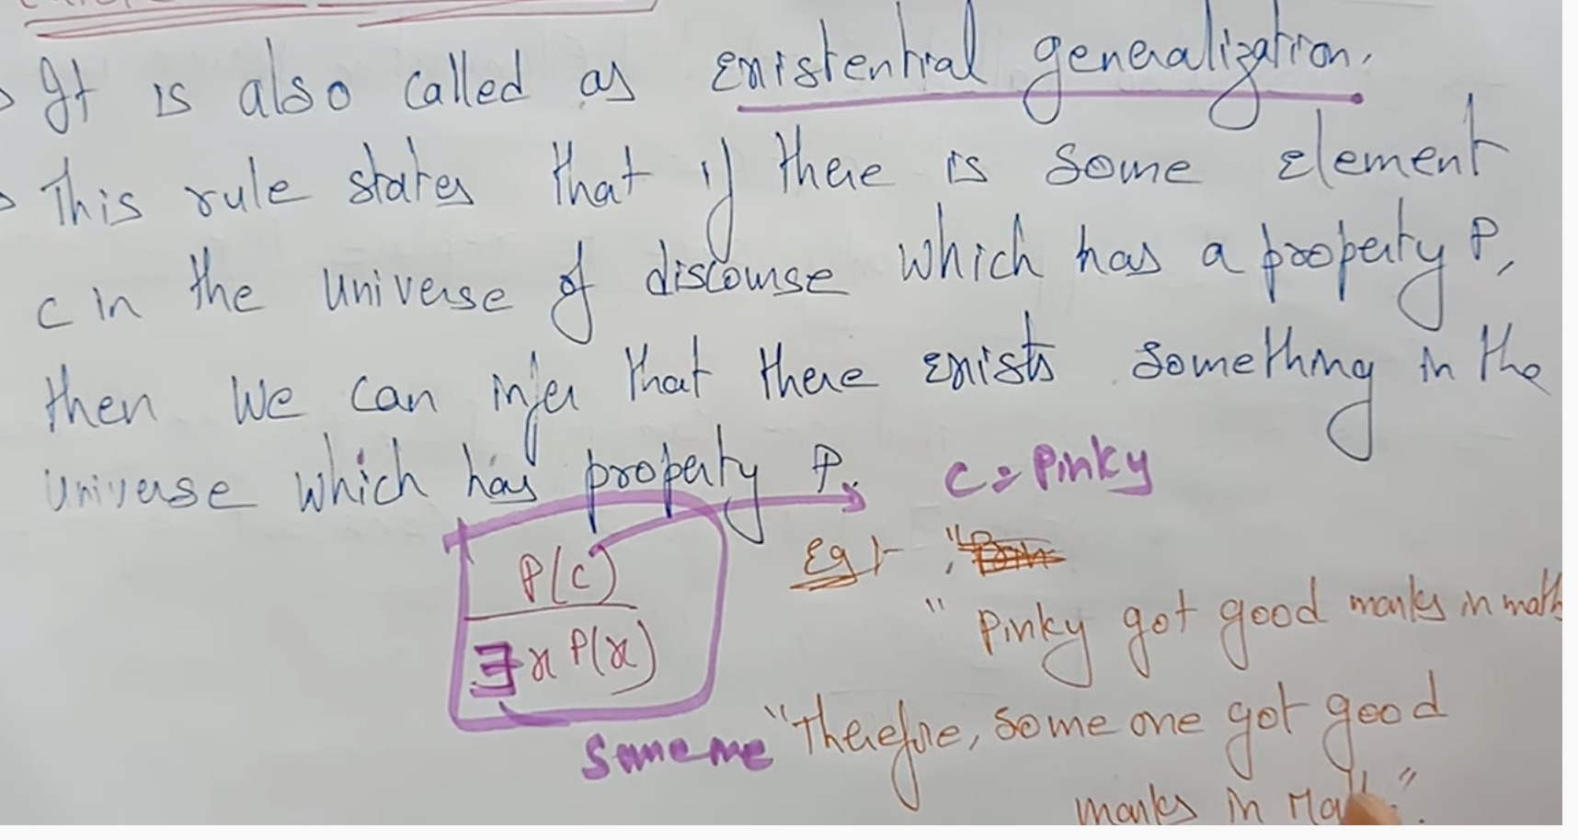

# **Unification in FOL**

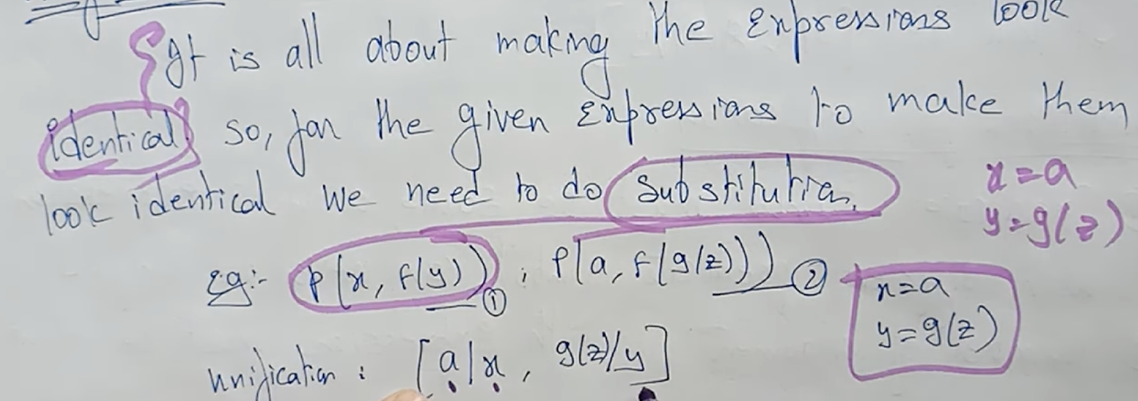

Both the equations 1 and 2 are identical to-each other.

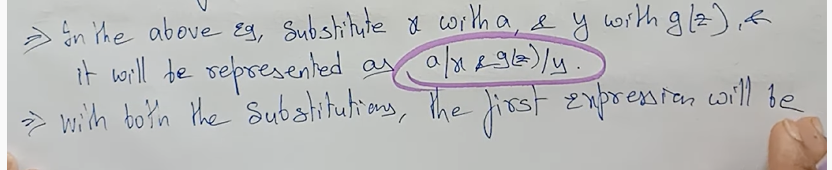  
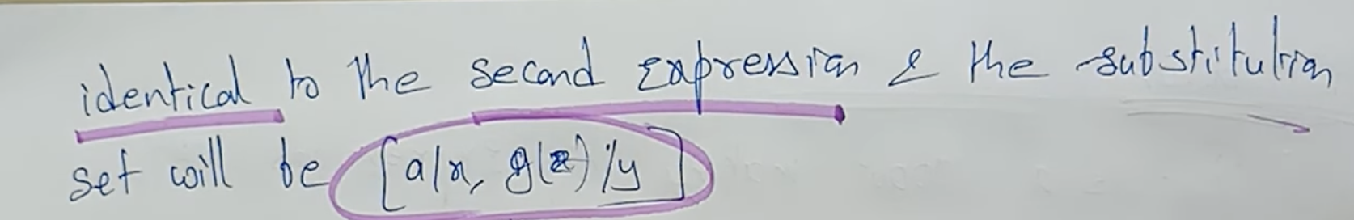

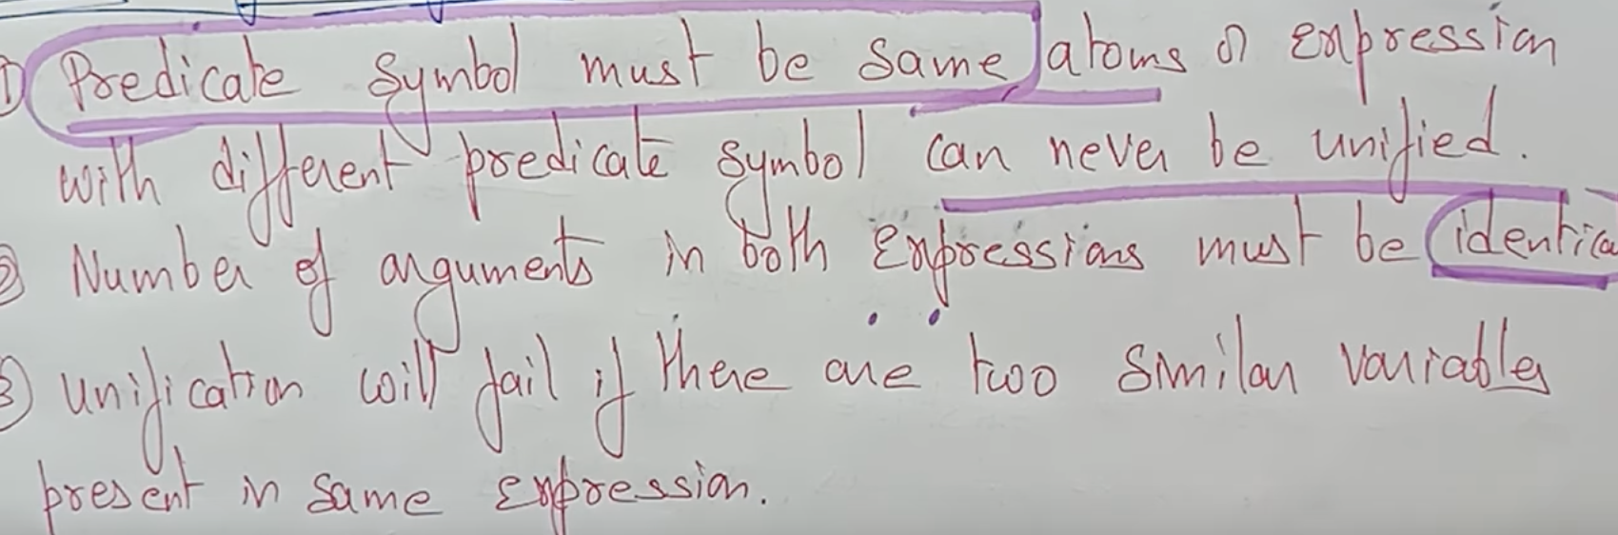

Check L1 and L2 are identical or not ??

2 similar variable in the same expression

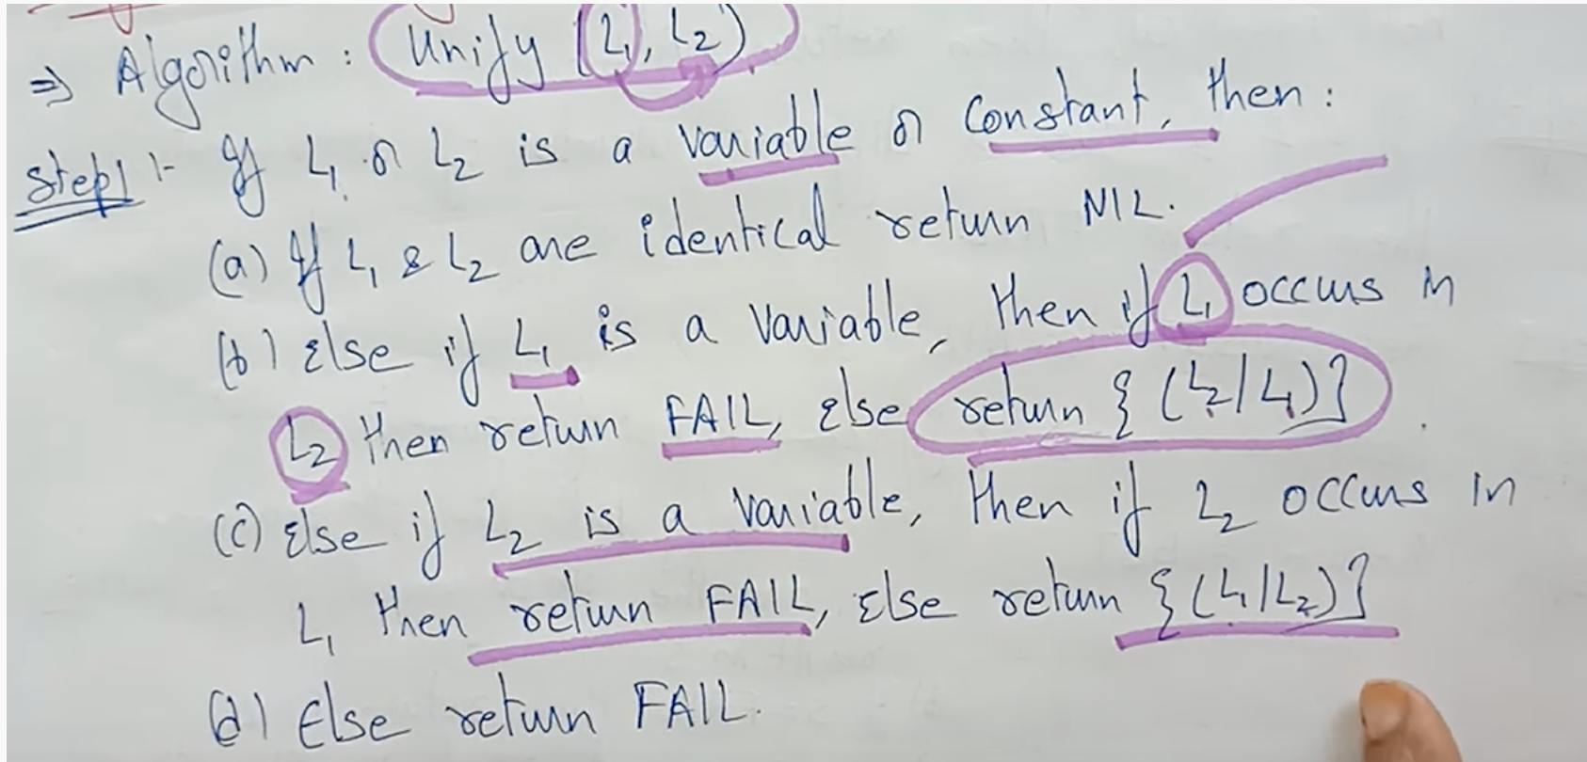

If L1 occurs in L2, then return L2/L1 (i.e substitute L1 in the place of L2)

If L2 occurs in L1, then return L1/L2 (i.e substitute L2 in the place of L1)

# **Resolution in FOL**

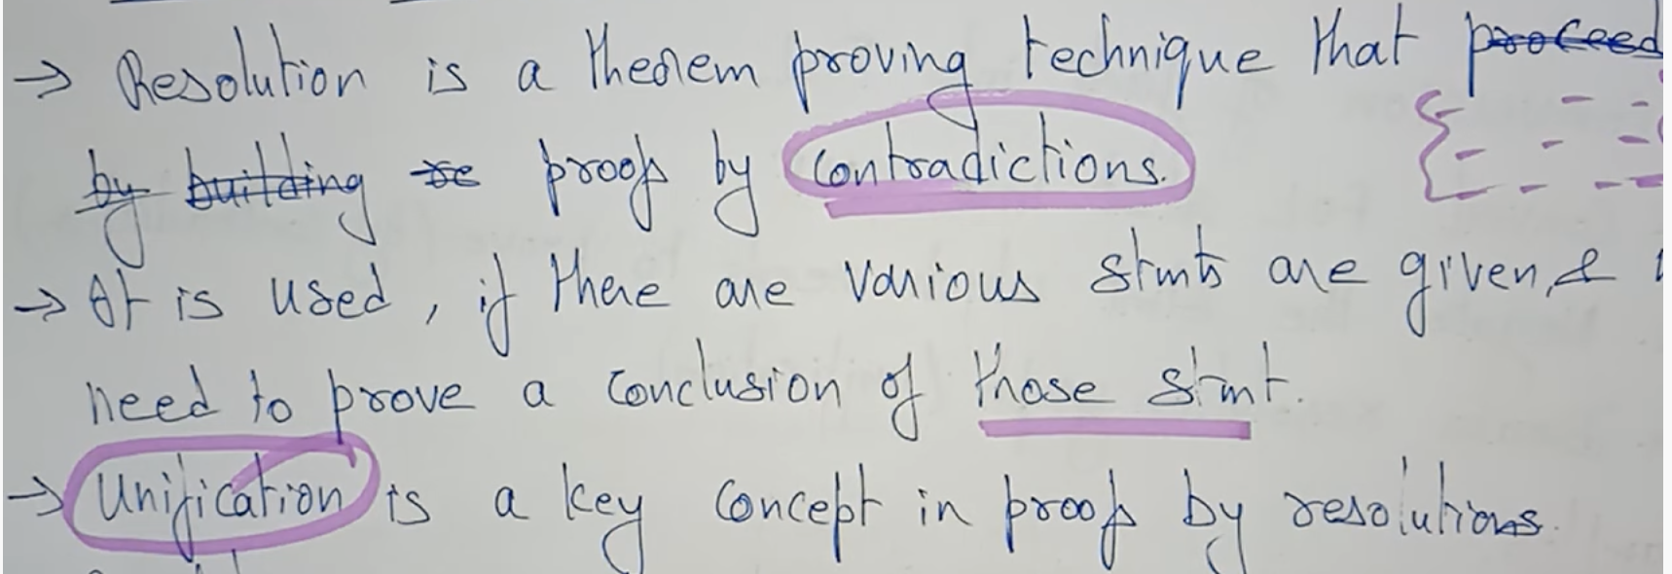  
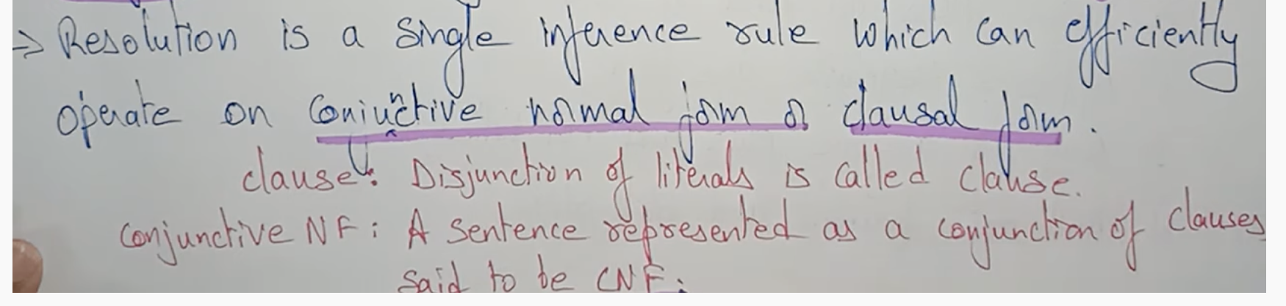

First Order Logic should be converted to CNF, then only we can prove by resolution.

## **Steps for the resolution**

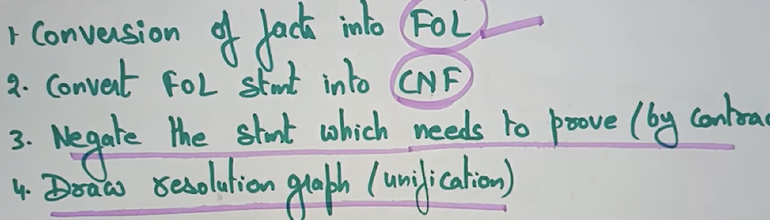

## **Examples**

